## 

**Project Report**

**On**

**DOOR TO DOOR SERVICES**

Submitted in partial fulfilment of the requirement for the VI semester

**Bachelor of Sciences in Information Technology**

By

**Charanjeet Singh Sidhu**

**Deepak Kumar**

**Gitesh Adhikari**

**Vijay Bhatt**

**Under the Guidance of**

Dr. Sudhanshu Maurya,

Assistant Professor, School of Computing, GEHU Bhimtal



**DEPARTMENT OF COMPUTER SCIENCE & ENGINEERING**

**GRAPHIC ERA HILL UNIVERSITY, BHIMTAL CAMPUS**

**SATTAL ROAD, P.O. BHOWALI,**

**DISTRICT- NAINITAL-263132**

**2018 – 2021**

## 

## INDEX

* **Students’ Declaration**
* **Certificate**
* **Acknowledgement**
* **Contents**
* **Introduction**
* **Proposed system**
* **S/W and H/W requirements (up to fullest extent)**
* **DFD (At least up to 2 level)**
* **Database Design (Applicable in case the project has DBMS at backend)**
* **ER diagram**
* **Coding of function**
* **Testing strategies**
* **Conclusion**
* **About Designers**
* **Bibliography/References**

**STUDENT’S DECLARATION**

We **Charanjeet Singh Sidhu, Deepak Kumar, Gitesh Adhikari & Vijay Bhatt** here by declare that the work, which is being presented in the project, entitled “Door to Door Services “In partial fulfilment of the requirement for the award of the degree **BACHELORS OF SCIENCES IN INFORMATION TECHNOLOGY & BACHELORS OF COMPUTER APPLICATIONS**  in the session **2020-2021**, is an authentic record of our own work carried out under the supervision of **Dr. Sudhanshu Maurya**.

The matter embodied in this project has not been submitted by us for the award of any other degree.

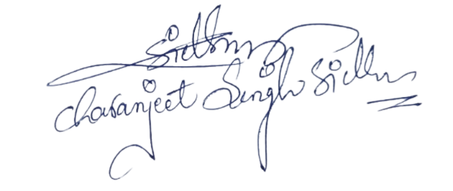Date:06-JUNE-2021 CHARANJEET SINGH SIDHU

(Full signature of student)

 DEEPAK KUMAR

(Full signature of student)

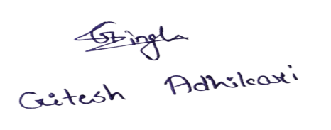 GITESH ADHIKARI

(Full signature of student)

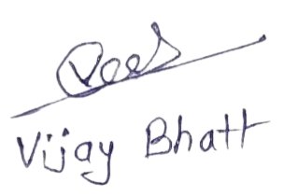 VIJAY BHATT

(Full signature of student)

**CERTIFICATE**

**The project report entitled “Door To Door Services” being submitted by Charanjeet Singh Sidhu S/o Mr. Rishpal Singh Sidhu enrollment no PV-18511034 Roll no 2072022 , Deepak Kumar S/o Mr. Puran Ram enrollment no PV-18710360 Roll no 2071360 , Gitesh Adhikari S/o Mr. Jeevansingh Adhikari enrollment no PV -18710351 Roll no 2071351 , Vijay Bhatt S/o Mr. Pitamber Bhatt enrollment no PV -18710396 Roll no 2071396 , to Graphic Era Hill University Bhimtal Campus for the award of bonafide work carried out by them. They have worked under my guidance and supervision and fulfilled the requirement for the submission of report.**

**(Dr. Sudhanshu Maurya) (Dr. Manoj Chandra Lohani)**

**Project Guide ( HOD, CSE Dept.)**

**ACKNOWLEDGEMENT**

I take immense pleasure in thanking Honourable **“Dr. Sudhanshu Maurya”** (**Assistant Professor,** **CS&A, GEHU Bhimtal Campus**) to permit us and carry out this project work with his excellent and optimistic supervision. This has all been possible due to his novel inspiration, able guidance and useful suggestions that helped me to develop as a creative researcher and complete the research work, in time.

Words are inadequate in offering my thanks to GOD for providing me everything that I need. I again want to extend thanks to our President **“Prof. (Dr.) Kamal Ghanshala”** for providing us all infrastructure and facilities to work in need without which this work could not be possible.

Many thanks to Professor **“Dr. Manoj Chandra Lohani”** (HOD-CS&A, GEHU), **“Dr. Naveen Tiwari”** **(Associate Professor**, CS&A, GEHU), and other faculties for their insightful comments, constructive suggestions, valuable advice, and time in reviewing this thesis.

Finally, yet importantly, I would like to express my heartiest thanks to my beloved parents, **“Mr. Rishpal Singh Sidhu”, “Puran Ram”, “Jeevansingh Adhikari”, “Pitamber Bhatt”** for their moral support, affection and blessings. I would also like to pay my sincere thanks to all my friends and well-wishers for their help and wishes for the successful completion of this research.

**(CHARANJEET SINGH SIDHU)**

[Sidhucharan53@gmail.com](mailto:Sidhucharan53@gmail.com)

**(DEEPAK KUMAR)**

[**Deepakkumararya1812@gmail.com**](mailto:Deepakkumararya1812@gmail.com)

**(GITESH ADHIKARI)**

[**Adhikarigitesh@gmail.com**](mailto:Adhikarigitesh@gmail.com)

**(VIJAY BHATT)**

**vijaybhatt1506@gmail.com**

**Table Of Contents**

**CHAPTER1: INTRODUCTION………………………………………….….07**

1.1 Prologue

1.2 Background and Motivations

**CHAPTER 2: PROPOSED SYSTEM 08**

2.1 Advantages

**CHAPTER 3: S/W AND H/W REQUIREMEN 09**

3.1 S/W and H/W requirements (up to fullest extent)

3.2 Security

**CHAPTER 4: DFD 12**

4.1 DFD

**CHAPTER 5: DATABASE DESIGN 14**

5.1 Database Design

**CHAPTER 6: ER DIAGRAM 19**

6.1 ER diagram

**CHAPTER 7: CODING OF FUNCTION 20**

**CHAPTER 8: TESTING STRATEGIES 57**

**CHAPTER 9: CONCLUSION………………………………………………….70**

**CHAPTER 10: ABOUT DESIGNERS……………………………………...…...71**

**CHAPTER 11: REFERENCES 72**

**1. INTRODUCTION**

**1.1 PROLOGUE**

In today’s life everyone is busy with their work and sometimes they don’t have enough time to visit stores or meet the person who can solve their issues.

So, we are here.

Our motto will help you to bring

YOUR IMAGINATION TO YOUR DOORSTEP.

**1.2BACKGROUND AND MOTIVATIONS**

This website will help you to get your daily needs at your doorstep. Even small to small services are available in it.

In this website you will be getting services like:

* Transport/Courier Service
* Product Delivery
* Grocery
* Technical Helper/ Adviser
* Electrician
* Cleaner
* Gardening
* Baby Sitting
* Food Order
* Event Management
* Healthcare/ Nursing
* Home Tutor
* Mechanical Helper/ Adviser

**2. PROPOSED SYSTEM**

**2.1 ADVANTAGES**

This website helps customers to

**1. Single Point of Contact for the Entire Delivery**

They do not need to maintain checks and balances at every stage of the shipment transfer. This means they only need to contact or add items to their “door2door services-delivery” account and confirm shipping.

**2. Added Advantage of Insurance**

With door-to-door delivery, the shipping provider also provides you with insurance for damaged and lost goods. Enquire about this with your delivery partner and ask if you need to activate it before, will they enable it automatically for every shipment

**3. Reduced Costs**

Door-to-door delivery does not require you to spend any additional costs at every stage of the fulfillment process. All the processes starting from the dispatch of products from your warehouse to the delivery of the product to the end customer, everything is done at one go. Therefore, customers do not need to arrange for any first-mile or last-mile delivery separately.

**4. Decreased Operational Efforts**

They do not have to waste time or efforts on resource and fleet management for logistics. You can spend this time on your core business, product development, etc.

With door-to-door delivery service, you can align resources toward marketing and sales of your product and overlook the entire logistics process.

**5. Easier to Manage3. S/W AND H/W REQUIREMENTS**

**3.1 S/W and H/W requirements**

**3.1.1Hardware Requirement**

* Laptop or Desktop with Configuration
* Main Memory(RAM 1gb and above)
* Primary Memory (ROM 500gb and above)
* Processor Intel core Processor ™ Duo
* Hard Disk Utilization :2.80 GHz
* External Hard Drive or DVDs for Backup. ...
* Camera.
* Server.
* Mobile Devices.
  + 1. **Software Requirement**
* Operating System: Windows, Mac Os or Linux
* Front End
* Notepad, Vs code or Notepad ++ (To code Html and CSS)
* Adobe Photoshop (For Image Editing)
* User Interface
  + Notepad, Vs code or Notepad ++ (To code JavaScript)
* Backend
  + Node JS and Mongo DB (To design Backend)
  + SQL (For table Designing in Backend)
* To implement the final Project

Browser

* + Google Chrome (vast used is Google Chrome for our Project)
  + Firefox
  + Internet Explorer
  1. **SECURITY**

**3.2.1 Use complex passwords**

On registration make sure user's passwords are at least eight characters long,

with a mix of upper and lower case, and include numbers or other characters,

and never use the auto-complete feature for passwords.

* + 1. **Store passwords in encrypted format**

**Use Crypt hashing function**

* This is to prevent rainbow table attacks which can reverse hashed passwords
* using common hashing functions that do not utilize a salt.
* Uses Hashing algorithms that are one-way functions.
* They turn any amount of data into a fixed-length “fingerprint” that cannot be reversed.

**3.2.3 Use two-factor authentication.**

Verify user by email-validation.

**3.2.4Captcha**

It determines whether the user is real or a spam robot.

CAPTCHAs stretch or manipulate letters and numbers, and rely on human ability

to determine which symbols, they are.

**3.2.5 Manage cookies**

At every 30 days server clear cookies and user needs to log in again.

**4. DFD (Data flow Diagram)**

**4.1 WEBSITE LAYOUT** 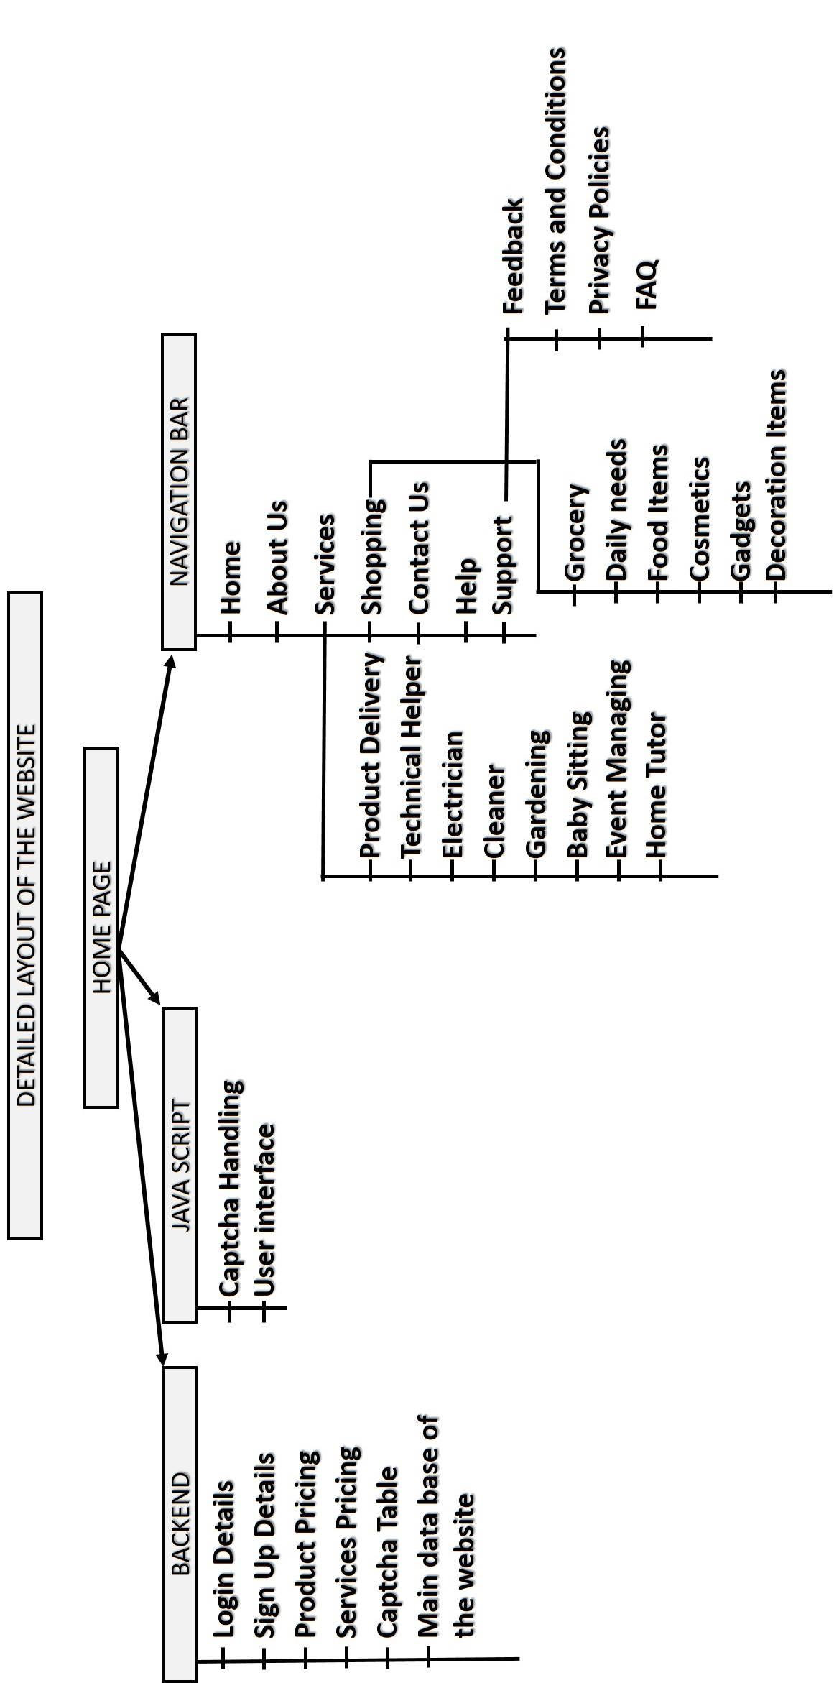

**4.2 DFD: Data flow Diagram**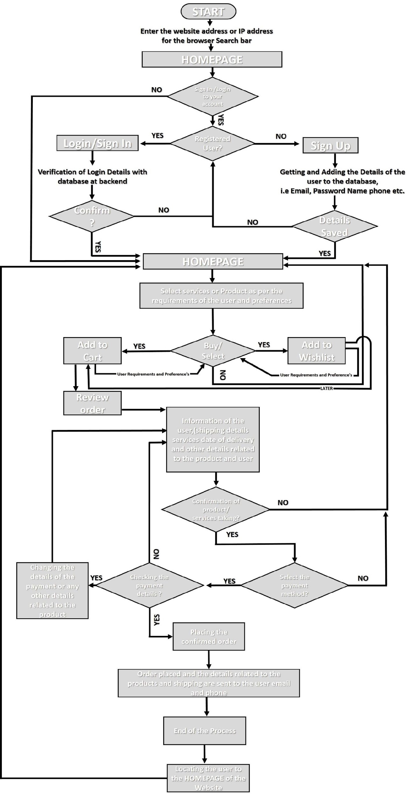

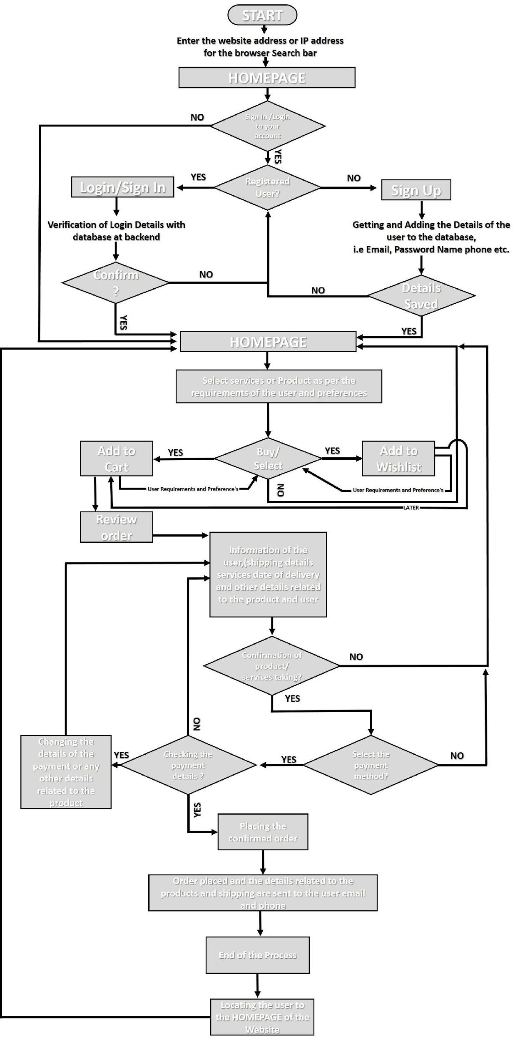

**5. DATABASE DESIGN (DB used : MongoDB )**

**5.1 DB Collections**

**users**

**id(object)**

**username(string)**

**email(string)**

**password(string)**

**token(string array)<-----store [cookies]**

**cart**

**messages(admin-inbox)**

**id(object)**

**name(string)**

**email(string)**

**subject(string)**

**message(string)**

**feedbacks/reports**

**id(object)**

**subject(string)**

**feedback/report(string)**

**product**

**id(object)**

**name(string)**

**AvailableItems(int)**

**img(string)**

**5.2 Various Screen Shots of the main page of the DB (DFD of the Project )**

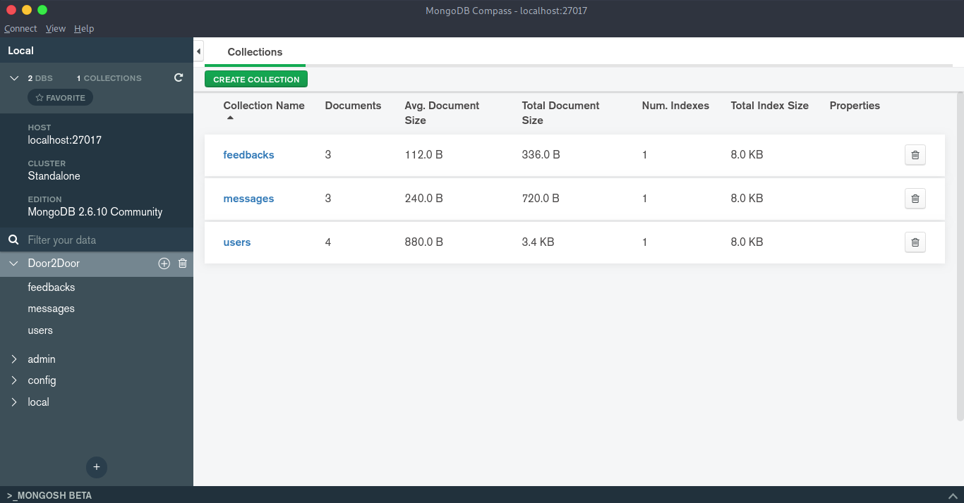

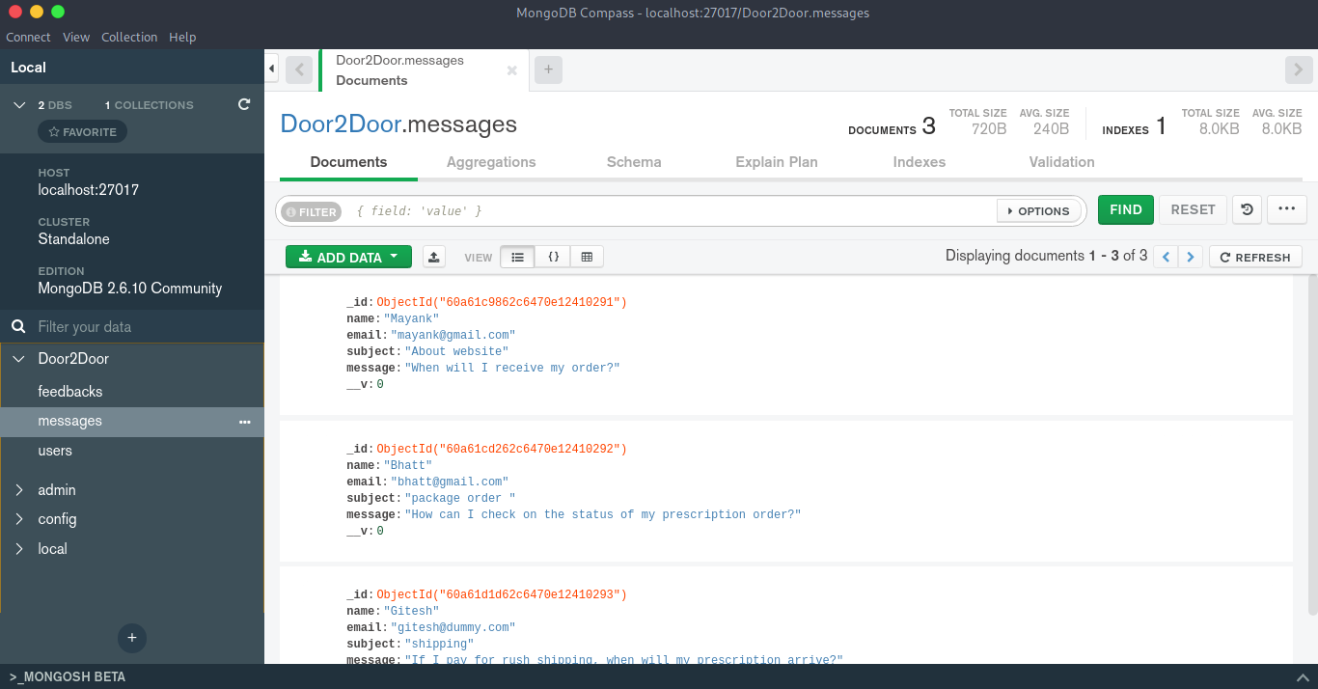

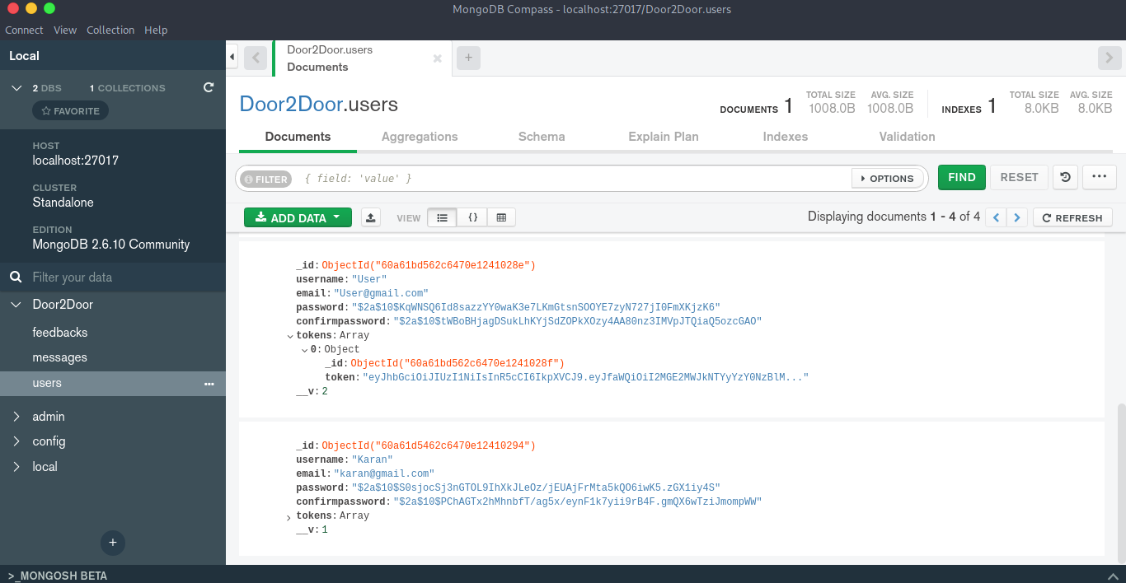**11. CONCLUSION**

Door-to-door delivery services might have multiple interpretations and different schools of thought, but it makes fulfillment and logistics a much easier task for you. If you haven’t yet, reach out to our website “door2door services/delivery” and start delivering your products or get services at your door soon!

No lifting and shifting heavy parcels. No need to go out – particularly useful when the weather is bad! No queuing at any door for products and home services at minimum prices.

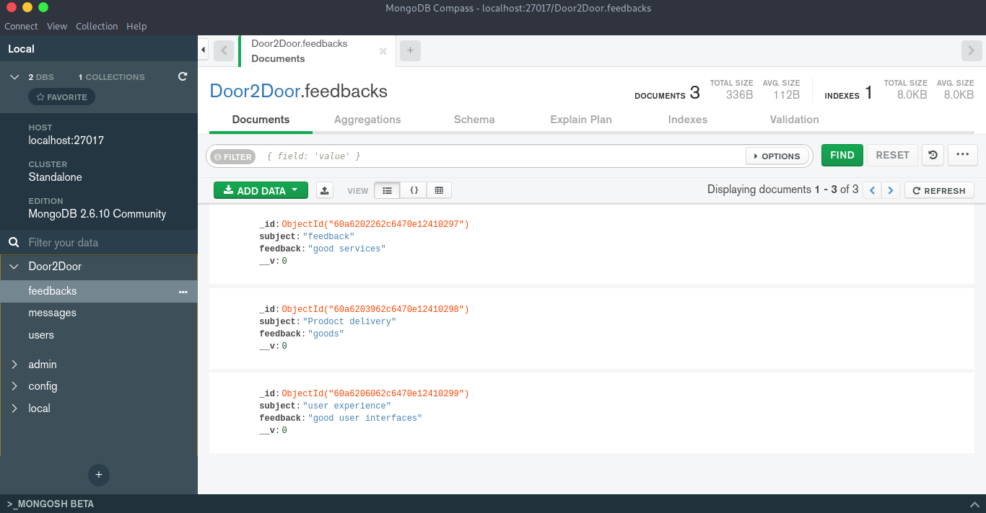

**6. ER DIAGRAM**

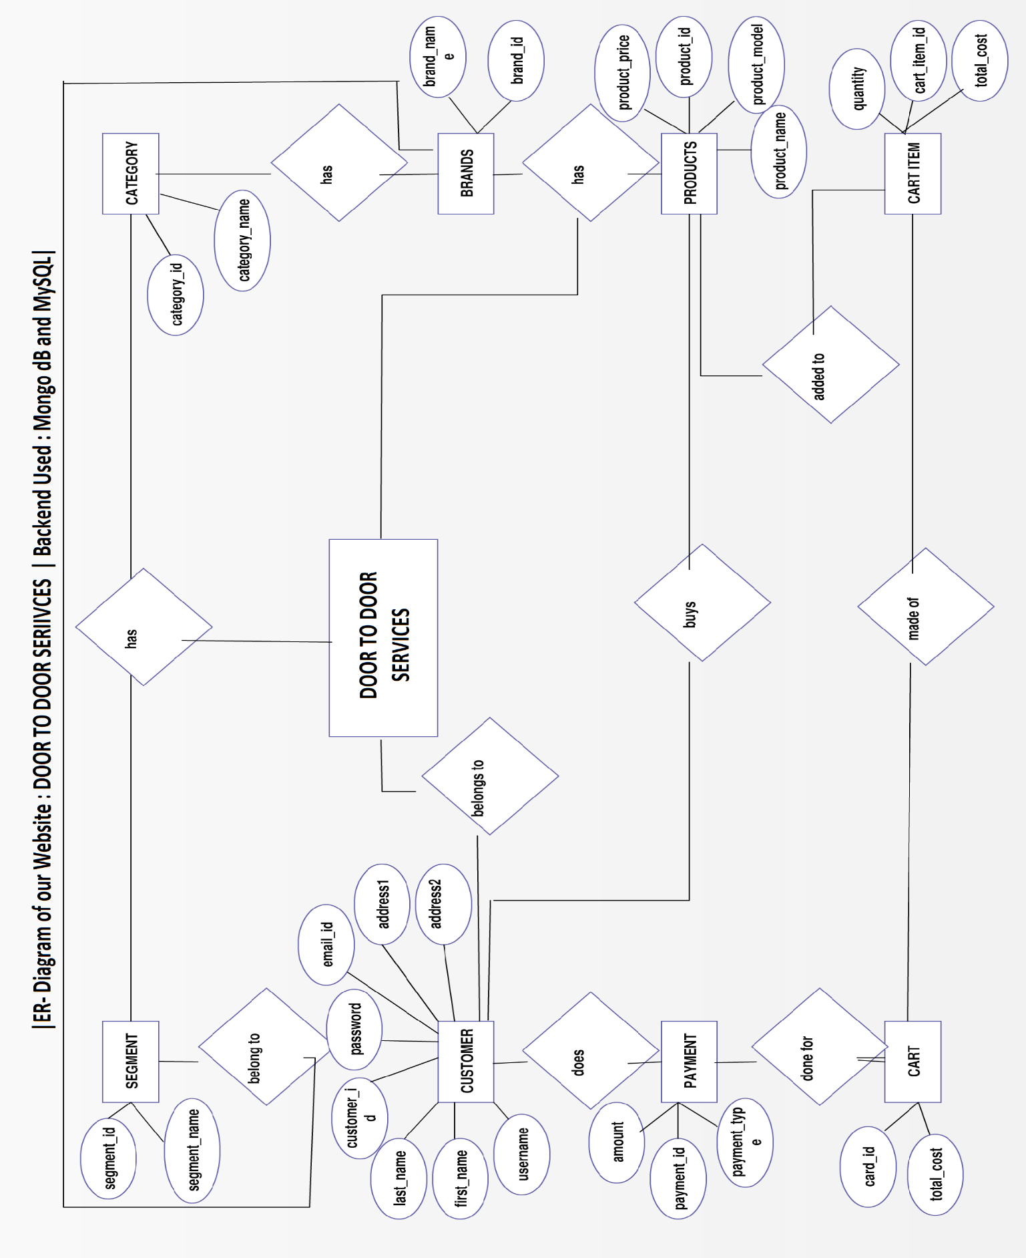**6.1 Er- Diagram of Project Database**

**7. CODING OF FUNCTION**

**7.1 CODING OF HOMEPAGE OF THE WEBSITE**

<!DOCTYPE html>

<html lang="en">

<head>

    <meta charset="UTF-8">

    <meta http-equiv="X-UA-Compatible" content="IE=edge">

    <meta name="viewport" content="width=device-width, initial-scale=1.0">

    <link rel="icon" href="assets/favicon/favicon.ico" type="image/x-icon" />

    <title>DoorToDoorService/Delivery</title>

    <link

        href="https://fonts.googleapis.com/css?family=Open+Sans:300,300i,400,400i,600,600i,700,700i|Raleway:300,300i,400,400i,500,500i,600,600i,700,700i|Poppins:300,300i,400,400i,500,500i,600,600i,700,700i"

        rel="stylesheet">

    <link href="vendor/aos/aos.css" rel="stylesheet">

    <link href="vendor/aos/aos.css" rel="stylesheet">

    <link href="vendor/bootstrap/css/bootstrap.min.css" rel="stylesheet">

    <link href="vendor/bootstrap-icons/bootstrap-icons.css" rel="stylesheet">

    <link href="vendor/boxicons/css/boxicons.min.css" rel="stylesheet">

    <link href="vendor/glightbox/css/glightbox.min.css" rel="stylesheet">

    <link href="vendor/swiper/swiper-bundle.min.css" rel="stylesheet">

    <link href="css/style.css" rel="stylesheet">

</head>

<body>

    <!-- ======= Top Bar ======= -->

    <section id="topbar" class="d-flex align-items-center">

        <div class="container d-flex justify-content-center justify-content-md-between">

            <div class="contact-info d-flex align-items-center">

                <i class="bi bi-envelope d-flex align-items-center"><a

                        href="mailto:contact@example.com">contact@example.com</a></i>

                <i class="bi bi-phone d-flex align-items-center ms-4"><a href="tel:+91 XXXXXXXXXX">+91

                        XXXXXXXXXX</a></i>

            </div>

            <div class="cta d-none d-md-flex align-items-center">

                <a href="signup" class="scrollto" style="color: white;background-color:#074885;">New User ? <i

                        class="bx bxs-user-plus"></i></a>

                <a href="signin" class="scrollto" style="color: white;background-color:#0e66b8;">Have An Account ! <i

                        class="bx bx-log-in"></i></a>

            </div>

        </div>

    </section>

    <!-- ======= Top Bar End ======= -->

    <!-- ======= Header ======= -->

    <header id="header" class="d-flex align-items-center">

        <div class="container d-flex align-items-center justify-content-between">

            <div class="logo">

                <h1><a href="/"><img src="assets/icon.png" alt="Icon" /></a></h1>

            </div>

            <!-- navbar -->

            <nav id="navbar" class="navbar">

                <ul>

                    <li><a class="nav-link scrollto active" href="/">Home</a></li>

                    <li><a class="nav-link scrollto" href="#">About Us</a></li>

                    <li class="dropdown"><a href="services"><span>Services</span> <i class="bi bi-chevron-down"></i></a>

                        <ul>

                            <li><a href="#">Product Delivery</a></li>

                            <li><a href="#">Technical Helper</a></li>

                            <li><a href="#">Electrician</a></li>

                            <li><a href="#">Cleaner</a></li>

                            <li><a href="#">Gardening</a></li>

                            <li><a href="#">Baby Sitting</a></li>

                            <li><a href="#">Event Management</a></li>

                            <li><a href="#">Home Tutor</a></li>

                        </ul>

                    </li>

                    <li class="dropdown"><a href="#"><span>Shopping</span> <i class="bi bi-chevron-down"></i></a>

                        <ul>

                            <li><a href="#">Grocery</a></li>

                            <li><a href="#">Daily Needs</a></li>

                            <li><a href="#">Food Items</a></li>

                            <li><a href="#">Cosmetics</a></li>

                            <li><a href="#">Gadgets</a></li>

                            <li><a href="#">Decoration</a></li>

                        </ul>

                    </li>

                    <li class="dropdown"><a href="#"><span>User</span> <i class="bi bi-chevron-down"></i></a>

                        <ul>

                            <li><a href="signup" id="signup">Sign Up</a></li>

                            <li><a href="signin" id="signin">Sign In</a></li>

                            <li><a href="user" id="user">My Account</a></li>

                            <li><a href="logout" id="logout">Log Out</a></li>

                        </ul>

                    </li>

                    <li class="dropdown"><a href="#"><span>Support</span> <i class="bi bi-chevron-down"></i></a>

                        <ul>

                            <li><a href="feedback">Feedback/Report</a></li>

                            <li><a href="contact">Contact Us</a></li>

                            <li><a href="#">Terms of Services</a></li>

                            <li><a href="#">Privacy Policy</a></li>

                            <li><a href="#">Help</a></li>

                            <li><a href="faq">FAQ</a></li>

                        </ul>

                    </li>

                </ul>

                <i class="bi bi-list mobile-nav-toggle"></i>

            </nav><!-- .navbar -->

        </div>

    </header><!-- End Header -->

    <!-- ======= Hero Section ======= -->

    <section id="hero" class="d-flex flex-column justify-content-center align-items-center">

        <div class="container" data-aos="fade-in">

            <h1>Welcome to Door to Door Service/Delivery</h1>

            <h2>Your Imagination To Your Door Steps</h2>

            <div class="d-flex align-items-center">

                <i class="bx bxs-right-arrow-alt get-started-icon"></i>

                <a href="#" class="btn-get-started scrollto">Get Started</a>

            </div>

        </div>

    </section><!-- End Hero -->

    <main id="main">

        <!-- Start #main -->

        <!-- ======= Why Us Section ======= -->

        <section id="why-us" class="why-us">

            <div class="container">

                <div class="row">

                    <div class="col-xl-4 col-lg-5" data-aos="fade-up">

                        <div class="content">

                            <h3>Why Choose Door2Door Service/Delivery?</h3>

                            <p>

                                Ours services might have multiple interpretations and different schools of thought, but

                                it makes fulfillment and logistics a much easier task for you.

                                No lifting and shifting heavy parcels. No need to go out – particularly useful when the

                                weather is bad! No queuing at any door for products and get home services at minimum

                                prices.

                            </p>

                            <div class="text-center">

                                <a href="#" class="more-btn">Learn More <i class="bx bx-chevron-right"></i></a>

                            </div>

                        </div>

                    </div>

                    <div class="col-xl-8 col-lg-7 d-flex">

                        <div class="icon-boxes d-flex flex-column justify-content-center">

                            <div class="row">

                                <div class="col-xl-4 d-flex align-items-stretch" data-aos="fade-up"

                                    data-aos-delay="300">

                                    <div class="icon-box mt-4 mt-xl-0">

                                        <i class="bx bx-dollar-circle"></i>

                                        <h4>Reduced Costs</h4>

                                        <p>Door-to-door delivery does not require you to spend any additional costs at

                                            every stage of the fulfillment process. Customers do not need to arrange for

                                            any first-mile or last-mile delivery separately.</p>

                                    </div>

                                </div>

                                <div class="col-xl-4 d-flex align-items-stretch" data-aos="fade-up"

                                    data-aos-delay="200">

                                    <div class="icon-box mt-4 mt-xl-0">

                                        <i class="bx bx-edit"></i>

                                        <h4>Easier to Manage</h4>

                                        <p>In door-to-door delivery service, You only need to stay in contact with one

                                            individual from the courier company. This enables you to conveniently manage

                                            the entire process and overlook it for timely delivery.</p>

                                    </div>

                                </div>

                                <div class="col-xl-4 d-flex align-items-stretch" data-aos="fade-up"

                                    data-aos-delay="100">

                                    <div class="icon-box mt-4 mt-xl-0">

                                        <i class="bx bx-receipt"></i>

                                        <h4>Single Point of Contact</h4>

                                        <p>Did not need to maintain checks and balances at every stage of the shipment

                                            transfer. This means you only need to contact or add items to their

                                            “Door2Door Services/Delivery” account and confirm shipping.</p>

                                    </div>

                                </div>

                            </div>

                        </div>

                    </div>

                </div>

            </div>

        </section>

        <!-- ======= Why Us Section ======= -->

        <!-- ======= Clients Section ======= -->

        <section id="clients" class="clients">

            <div class="container" data-aos="fade-up">

                <div class="clients-slider swiper-container">

                    <div class="swiper-wrapper align-items-center">

                        <div class="swiper-slide"><img src="assets/img/clients/client-1.png" class="img-fluid" alt="">

                        </div>

                        <div class="swiper-slide"><img src="assets/img/clients/client-2.png" class="img-fluid" alt="">

                        </div>

                        <div class="swiper-slide"><img src="assets/img/clients/client-3.png" class="img-fluid" alt="">

                        </div>

                        <div class="swiper-slide"><img src="assets/img/clients/client-4.png" class="img-fluid" alt="">

                        </div>

                        <div class="swiper-slide"><img src="assets/img/clients/client-5.png" class="img-fluid" alt="">

                        </div>

                        <div class="swiper-slide"><img src="assets/img/clients/client-6.png" class="img-fluid" alt="">

                        </div>

                        <div class="swiper-slide"><img src="assets/img/clients/client-7.png" class="img-fluid" alt="">

                        </div>

                        <div class="swiper-slide"><img src="assets/img/clients/client-8.png" class="img-fluid" alt="">

                        </div>

                    </div>

                    <div class="swiper-pagination"></div>

                </div>

            </div>

        </section><!-- End Clients Section -->

        <!-- ======= Services Section ======= -->

        <section id="services" class="services section-bg">

            <div class="container">

                <div class="section-title" data-aos="fade-up">

                    <h2>Services</h2>

                    <p>This website will help you to get your daily needs at your doorstep. Even small to small services

                        are available. In this website you will be getting services like:</p>

                </div>

                <div class="row">

                    <div class="col-lg-4 col-md-6" data-aos="fade-up">

                        <div class="icon-box">

                            <div class="icon"><i class="bi bi-briefcase"></i></div>

                            <h4 class="title"><a href="">Product Delivery</a></h4>

                            <p class="description">a continuous flow of valuable products and services to customers and

                                users</p>

                        </div>

                    </div>

                    <div class="col-lg-4 col-md-6" data-aos="fade-up" data-aos-delay="100">

                        <div class="icon-box">

                            <div class="icon"><i class="bi bi-card-checklist"></i></div>

                            <h4 class="title"><a href="">Technical Helper/ Adviser</a></h4>

                            <p class="description">develop applications, coordinate the activities of technicians, and

                                provide technical expertise</p>

                        </div>

                    </div>

                    <div class="col-lg-4 col-md-6" data-aos="fade-up" data-aos-delay="200">

                        <div class="icon-box">

                            <div class="icon"><i class="bi bi-lightbulb"></i></div>

                            <h4 class="title"><a href="">Electrician</a></h4>

                            <p class="description">inspecting, testing, repairing, installing, and modifying electrical

                                components and systems</p>

                        </div>

                    </div>

                    <div class="col-lg-4 col-md-6" data-aos="fade-up" data-aos-delay="300">

                        <div class="icon-box">

                            <div class="icon"><i class="bi bi-binoculars"></i></div>

                            <h4 class="title"><a href="">Event Management</a></h4>

                            <p class="description">creation and development of small and/or large-scale personal or

                                corporate events </p>

                        </div>

                    </div>

                    <div class="col-lg-4 col-md-6" data-aos="fade-up" data-aos-delay="400">

                        <div class="icon-box">

                            <div class="icon"><i class="bi bi-stars"></i></div>

                            <h4 class="title"><a href="">Cleaner</a></h4>

                            <p class="description">clean houses, offices, public places, etc.</p>

                        </div>

                    </div>

                    <div class="col-lg-4 col-md-6" data-aos="fade-up" data-aos-delay="500">

                        <div class="icon-box">

                            <div class="icon"><i class="bi bi-flower3"></i></div>

                            <h4 class="title"><a href="">Gardening</a></h4>

                            <p class="description">monitoring the health of all plants and greenscapes, watering and

                                feeding plants, trimming trees and shrubs, and much more</p>

                        </div>

                    </div>

                </div>

            </div>

        </section><!-- End Services Section -->

        <!-- ======= Values Section ======= -->

        <section id="values" class="values">

            <div class="container">

                <div class="row">

                    <div class="col-md-6 d-flex align-items-stretch" data-aos="fade-up">

                        <div class="card" style="background-image: url(assets/img/values-1.jpg);">

                            <div class="card-body">

                                <h5 class="card-title"><a href="">Our Mission</a></h5>

                                <p class="card-text">In today’s life everyone is busy with their work and sometimes they

                                    don’t have enough time to visit stores or meet the person who can solve their

                                    issues.</p>

                                <div class="read-more"><a href="#"><i class="bi bi-arrow-right"></i> Read More</a></div>

                            </div>

                        </div>

                    </div>

                    <div class="col-md-6 d-flex align-items-stretch mt-4 mt-md-0" data-aos="fade-up"

                        data-aos-delay="100">

                        <div class="card" style="background-image: url(assets/img/values-2.jpg);">

                            <div class="card-body">

                                <h5 class="card-title"><a href="">Our Plan</a></h5>

                                <p class="card-text">No queuing at any door for products and get home services at

                                    minimum prices.</p>

                                <div class="read-more"><a href="#"><i class="bi bi-arrow-right"></i> Read More</a></div>

                            </div>

                        </div>

                    </div>

                    <div class="col-md-6 d-flex align-items-stretch mt-4" data-aos="fade-up" data-aos-delay="200">

                        <div class="card" style="background-image: url(assets/img/values-3.jpg);">

                            <div class="card-body">

                                <h5 class="card-title"><a href="">Our Vision</a></h5>

                                <p class="card-text">You can target specific verticals or niches using online marketing.

                                </p>

                                <div class="read-more"><a href="#"><i class="bi bi-arrow-right"></i> Read More</a></div>

                            </div>

                        </div>

                    </div>

                    <div class="col-md-6 d-flex align-items-stretch mt-4" data-aos="fade-up" data-aos-delay="300">

                        <div class="card" style="background-image: url(assets/img/values-4.jpg);">

                            <div class="card-body">

                                <h5 class="card-title"><a href="">Our Care</a></h5>

                                <p class="card-text"> We conducted a survey of over 1,000 buyers of professional

                                    services for a providing you more services and products.</p>

                                <div class="read-more"><a href="#"><i class="bi bi-arrow-right"></i> Read More</a></div>

                            </div>

                        </div>

                    </div>

                </div>

            </div>

        </section><!-- End Values Section -->

        <!-- ======= Testimonials Section ======= -->

        <section id="testimonials" class="testimonials">

            <div class="container position-relative" data-aos="fade-up">

                <div class="testimonials-slider swiper-container" data-aos="fade-up" data-aos-delay="100">

                    <div class="swiper-wrapper">

                        <div class="swiper-slide">

                            <div class="testimonial-item">

                                <img src="assets/img/testimonials/testimonials-1.jpg" class="testimonial-img" alt="">

                                <h3>Saul Goodman</h3>

                                <h4>Ceo &amp; Founder</h4>

                                <p>

                                    <i class="bx bxs-quote-alt-left quote-icon-left"></i>

                                    Proin iaculis purus consequat sem cure digni ssim donec porttitora entum suscipit

                                    rhoncus. Accusantium quam, ultricies eget id, aliquam eget nibh et. Maecen aliquam,

                                    risus at semper.

                                    <i class="bx bxs-quote-alt-right quote-icon-right"></i>

                                </p>

                            </div>

                        </div><!-- End testimonial item -->

                        <div class="swiper-slide">

                            <div class="testimonial-item">

                                <img src="assets/img/testimonials/testimonials-2.jpg" class="testimonial-img" alt="">

                                <h3>Sara Wilsson</h3>

                                <h4>Designer</h4>

                                <p>

                                    <i class="bx bxs-quote-alt-left quote-icon-left"></i>

                                    Export tempor illum tamen malis malis eram quae irure esse labore quem cillum quid

                                    cillum eram malis quorum velit fore eram velit sunt aliqua noster fugiat irure amet

                                    legam anim culpa.

                                    <i class="bx bxs-quote-alt-right quote-icon-right"></i>

                                </p>

                            </div>

                        </div><!-- End testimonial item -->

                        <div class="swiper-slide">

                            <div class="testimonial-item">

                                <img src="assets/img/testimonials/testimonials-3.jpg" class="testimonial-img" alt="">

                                <h3>Jena Karlis</h3>

                                <h4>Store Owner</h4>

                                <p>

                                    <i class="bx bxs-quote-alt-left quote-icon-left"></i>

                                    Enim nisi quem export duis labore cillum quae magna enim sint quorum nulla quem

                                    veniam duis minim tempor labore quem eram duis noster aute amet eram fore quis sint

                                    minim.

                                    <i class="bx bxs-quote-alt-right quote-icon-right"></i>

                                </p>

                            </div>

                        </div><!-- End testimonial item -->

                        <div class="swiper-slide">

                            <div class="testimonial-item">

                                <img src="assets/img/testimonials/testimonials-4.jpg" class="testimonial-img" alt="">

                                <h3>Matt Brandon</h3>

                                <h4>Freelancer</h4>

                                <p>

                                    <i class="bx bxs-quote-alt-left quote-icon-left"></i>

                                    Fugiat enim eram quae cillum dolore dolor amet nulla culpa multos export minim

                                    fugiat minim velit minim dolor enim duis veniam ipsum anim magna sunt elit fore quem

                                    dolore labore illum veniam.

                                    <i class="bx bxs-quote-alt-right quote-icon-right"></i>

                                </p>

                            </div>

                        </div><!-- End testimonial item -->

                        <div class="swiper-slide">

                            <div class="testimonial-item">

                                <img src="assets/img/testimonials/testimonials-5.jpg" class="testimonial-img" alt="">

                                <h3>John Larson</h3>

                                <h4>Entrepreneur</h4>

                                <p>

                                    <i class="bx bxs-quote-alt-left quote-icon-left"></i>

                                    Quis quorum aliqua sint quem legam fore sunt eram irure aliqua veniam tempor noster

                                    veniam enim culpa labore duis sunt culpa nulla illum cillum fugiat legam esse veniam

                                    culpa fore nisi cillum quid.

                                    <i class="bx bxs-quote-alt-right quote-icon-right"></i>

                                </p>

                            </div>

                        </div><!-- End testimonial item -->

                    </div>

                    <div class="swiper-pagination"></div>

                </div>

            </div>

        </section><!-- End Testimonials Section -->

        <!-- ======= Portfolio Section ======= -->

        <section id="portfolio" class="portfolio">

            <div class="container">

                <div class="section-title">

                    <h2 data-aos="fade-up">Shopping</h2>

                    <p data-aos="fade-up">Browses the available goods or services presented by one or more retailers

                        with the potential intent to purchase a suitable selection of them.</p>

                </div>

                <div class="row" data-aos="fade-up" data-aos-delay="100">

                    <div class="col-lg-12 d-flex justify-content-center">

                        <ul id="portfolio-flters">

                            <li data-filter="*" class="filter-active">All</li>

                            <li data-filter=".filter-app">Most Buying</li>

                            <li data-filter=".filter-card">Available At Least Prices</li>

                            <li data-filter=".filter-web">For Party</li>

                        </ul>

                    </div>

                </div>

                <div class="row portfolio-container" data-aos="fade-up" data-aos-delay="200">

                    <div class="col-lg-4 col-md-6 portfolio-item filter-app">

                        <img src="assets/img/portfolio/portfolio-1.jpg" class="img-fluid" alt="">

                        <div class="portfolio-info">

                            <h4>App 1</h4>

                            <p>App</p>

                            <a href="assets/img/portfolio/portfolio-1.jpg" data-gallery="portfolioGallery"

                                class="portfolio-lightbox preview-link" title="App 1"><i class="bx bx-plus"></i></a>

                            <a href="portfolio-details.html" class="details-link" title="More Details"><i

                                    class="bx bx-link"></i></a>

                        </div>

                    </div>

                    <div class="col-lg-4 col-md-6 portfolio-item filter-web">

                        <img src="assets/img/portfolio/portfolio-2.jpg" class="img-fluid" alt="">

                        <div class="portfolio-info">

                            <h4>Web 3</h4>

                            <p>Web</p>

                            <a href="assets/img/portfolio/portfolio-2.jpg" data-gallery="portfolioGallery"

                                class="portfolio-lightbox preview-link" title="Web 3"><i class="bx bx-plus"></i></a>

                            <a href="portfolio-details.html" class="details-link" title="More Details"><i

                                    class="bx bx-link"></i></a>

                        </div>

                    </div>

                    <div class="col-lg-4 col-md-6 portfolio-item filter-app">

                        <img src="assets/img/portfolio/portfolio-3.jpg" class="img-fluid" alt="">

                        <div class="portfolio-info">

                            <h4>App 2</h4>

                            <p>App</p>

                            <a href="assets/img/portfolio/portfolio-3.jpg" data-gallery="portfolioGallery"

                                class="portfolio-lightbox preview-link" title="App 2"><i class="bx bx-plus"></i></a>

                            <a href="portfolio-details.html" class="details-link" title="More Details"><i

                                    class="bx bx-link"></i></a>

                        </div>

                    </div>

                    <div class="col-lg-4 col-md-6 portfolio-item filter-card">

                        <img src="assets/img/portfolio/portfolio-4.jpg" class="img-fluid" alt="">

                        <div class="portfolio-info">

                            <h4>Card 2</h4>

                            <p>Card</p>

                            <a href="assets/img/portfolio/portfolio-4.jpg" data-gallery="portfolioGallery"

                                class="portfolio-lightbox preview-link" title="Card 2"><i class="bx bx-plus"></i></a>

                            <a href="portfolio-details.html" class="details-link" title="More Details"><i

                                    class="bx bx-link"></i></a>

                        </div>

                    </div>

                    <div class="col-lg-4 col-md-6 portfolio-item filter-web">

                        <img src="assets/img/portfolio/portfolio-5.jpg" class="img-fluid" alt="">

                        <div class="portfolio-info">

                            <h4>Web 2</h4>

                            <p>Web</p>

                            <a href="assets/img/portfolio/portfolio-5.jpg" data-gallery="portfolioGallery"

                                class="portfolio-lightbox preview-link" title="Web 2"><i class="bx bx-plus"></i></a>

                            <a href="portfolio-details.html" class="details-link" title="More Details"><i

                                    class="bx bx-link"></i></a>

                        </div>

                    </div>

                    <div class="col-lg-4 col-md-6 portfolio-item filter-app">

                        <img src="assets/img/portfolio/portfolio-6.jpg" class="img-fluid" alt="">

                        <div class="portfolio-info">

                            <h4>App 3</h4>

                            <p>App</p>

                            <a href="assets/img/portfolio/portfolio-6.jpg" data-gallery="portfolioGallery"

                                class="portfolio-lightbox preview-link" title="App 3"><i class="bx bx-plus"></i></a>

                            <a href="portfolio-details.html" class="details-link" title="More Details"><i

                                    class="bx bx-link"></i></a>

                        </div>

                    </div>

                    <div class="col-lg-4 col-md-6 portfolio-item filter-card">

                        <img src="assets/img/portfolio/portfolio-7.jpg" class="img-fluid" alt="">

                        <div class="portfolio-info">

                            <h4>Card 1</h4>

                            <p>Card</p>

                            <a href="assets/img/portfolio/portfolio-7.jpg" data-gallery="portfolioGallery"

                                class="portfolio-lightbox preview-link" title="Card 1"><i class="bx bx-plus"></i></a>

                            <a href="portfolio-details.html" class="details-link" title="More Details"><i

                                    class="bx bx-link"></i></a>

                        </div>

                    </div>

                    <div class="col-lg-4 col-md-6 portfolio-item filter-card">

                        <img src="assets/img/portfolio/portfolio-8.jpg" class="img-fluid" alt="">

                        <div class="portfolio-info">

                            <h4>Card 3</h4>

                            <p>Card</p>

                            <a href="assets/img/portfolio/portfolio-8.jpg" data-gallery="portfolioGallery"

                                class="portfolio-lightbox preview-link" title="Card 3"><i class="bx bx-plus"></i></a>

                            <a href="portfolio-details.html" class="details-link" title="More Details"><i

                                    class="bx bx-link"></i></a>

                        </div>

                    </div>

                    <div class="col-lg-4 col-md-6 portfolio-item filter-web">

                        <img src="assets/img/portfolio/portfolio-9.jpg" class="img-fluid" alt="">

                        <div class="portfolio-info">

                            <h4>Web 3</h4>

                            <p>Web</p>

                            <a href="assets/img/portfolio/portfolio-9.jpg" data-gallery="portfolioGallery"

                                class="portfolio-lightbox preview-link" title="Web 3"><i class="bx bx-plus"></i></a>

                            <a href="portfolio-details.html" class="details-link" title="More Details"><i

                                    class="bx bx-link"></i></a>

                        </div>

                    </div>

                </div>

            </div>

        </section><!-- End Portfolio Section -->

        <!-- ======= Team Section ======= -->

        <section id="team" class="team section-bg">

            <div class="container">

                <div class="section-title">

                    <h2 data-aos="fade-up">Team</h2>

                    <p data-aos="fade-up">Let meet our talented human resource.</p>

                </div>

                <div class="row">

                    <div class="col-lg-3 col-md-6 d-flex align-items-stretch" data-aos="fade-up">

                        <div class="member">

                            <div class="member-img">

                                <img src="assets/img/team/team-1.jpg" class="img-fluid" alt="">

                                <div class="social">

                                    <a href=""><i class="bi bi-twitter"></i></a>

                                    <a href=""><i class="bi bi-facebook"></i></a>

                                    <a href=""><i class="bi bi-instagram"></i></a>

                                    <a href=""><i class="bi bi-linkedin"></i></a>

                                </div>

                            </div>

                            <div class="member-info">

                                <h4>Adhikari Gitesh</h4>

                                <span>Team Leader</span>

                            </div>

                        </div>

                    </div>

                    <div class="col-lg-3 col-md-6 d-flex align-items-stretch" data-aos="fade-up" data-aos-delay="100">

                        <div class="member">

                            <div class="member-img">

                                <img src="assets/img/team/team-2.jpg" class="img-fluid" alt="">

                                <div class="social">

                                    <a href=""><i class="bi bi-twitter"></i></a>

                                    <a href=""><i class="bi bi-facebook"></i></a>

                                    <a href=""><i class="bi bi-instagram"></i></a>

                                    <a href=""><i class="bi bi-linkedin"></i></a>

                                </div>

                            </div>

                            <div class="member-info">

                                <h4>Charanjeet Singh Sidhu</h4>

                                <span>Front End Developer</span>

                            </div>

                        </div>

                    </div>

                    <div class="col-lg-3 col-md-6 d-flex align-items-stretch" data-aos="fade-up" data-aos-delay="200">

                        <div class="member">

                            <div class="member-img">

                                <img src="assets/img/team/team-3.jpg" class="img-fluid" alt="">

                                <div class="social">

                                    <a href=""><i class="bi bi-twitter"></i></a>

                                    <a href=""><i class="bi bi-facebook"></i></a>

                                    <a href=""><i class="bi bi-instagram"></i></a>

                                    <a href=""><i class="bi bi-linkedin"></i></a>

                                </div>

                            </div>

                            <div class="member-info">

                                <h4>Deepak Kumar</h4>

                                <span>Backend Developer</span>

                            </div>

                        </div>

                    </div>

                    <div class="col-lg-3 col-md-6 d-flex align-items-stretch" data-aos="fade-up" data-aos-delay="300">

                        <div class="member">

                            <div class="member-img">

                                <img src="assets/img/team/team-4.jpg" class="img-fluid" alt="">

                                <div class="social">

                                    <a href=""><i class="bi bi-twitter"></i></a>

                                    <a href=""><i class="bi bi-facebook"></i></a>

                                    <a href=""><i class="bi bi-instagram"></i></a>

                                    <a href=""><i class="bi bi-linkedin"></i></a>

                                </div>

                            </div>

                            <div class="member-info">

                                <h4>Vijay Bhatt</h4>

                                <span>Blogger</span>

                            </div>

                        </div>

                    </div>

                </div>

            </div>

        </section><!-- End Team Section -->

        <!-- ======= F.A.Q Section ======= -->

        <section id="faq" class="faq section-bg">

            <div class="container">

                <div class="section-title">

                    <h2 data-aos="fade-up">F.A.Q</h2>

                    <p data-aos="fade-up">Need any help? Check out solution of some common problems.</p>

                </div>

                <div class="faq-list">

                    <ul>

                        <li data-aos="fade-up">

                            <i class="bx bx-help-circle icon-help"></i> <a data-bs-toggle="collapse" class="collapse"

                                data-bs-target="#faq-list-1">If I order in bulk do I receive a discount?<i

                                    class="bx bx-chevron-down icon-show"></i><i

                                    class="bx bx-chevron-up icon-close"></i></a>

                            <div id="faq-list-1" class="collapse show" data-bs-parent=".faq-list">

                                <p>

                                    Contact us for more information on bulk ordering.

                                </p>

                            </div>

                        </li>

                        <li data-aos="fade-up" data-aos-delay="100">

                            <i class="bx bx-help-circle icon-help"></i> <a data-bs-toggle="collapse"

                                data-bs-target="#faq-list-2" class="collapsed">Does Door2Door Service/Delivery accept

                                returns?<i class="bx bx-chevron-down icon-show"></i><i

                                    class="bx bx-chevron-up icon-close"></i></a>

                            <div id="faq-list-2" class="collapse" data-bs-parent=".faq-list">

                                <p>

                                    Doors are purchased as is and we do not accept returns.

                                </p>

                            </div>

                        </li>

                        <li data-aos="fade-up" data-aos-delay="200">

                            <i class="bx bx-help-circle icon-help"></i> <a data-bs-toggle="collapse"

                                data-bs-target="#faq-list-3" class="collapsed">Does Door2Door Service/Delivery offer a

                                warranty on its products? <i class="bx bx-chevron-down icon-show"></i><i

                                    class="bx bx-chevron-up icon-close"></i></a>

                            <div id="faq-list-3" class="collapse" data-bs-parent=".faq-list">

                                <p>

                                    A-grade doors are warrantied for 1-year from date of purchase. Doors with blemishes

                                    are specially priced, and not warrantied. <a href="">For more information on our

                                        warranty policy, click here</a>

                                </p>

                            </div>

                        </li>

                        <li data-aos="fade-up" data-aos-delay="300">

                            <i class="bx bx-help-circle icon-help"></i> <a data-bs-toggle="collapse"

                                data-bs-target="#faq-list-4" class="collapsed">Will you use your own vacuum cleaner and

                                cleaning supplies or ours?<i class="bx bx-chevron-down icon-show"></i><i

                                    class="bx bx-chevron-up icon-close"></i></a>

                            <div id="faq-list-4" class="collapse" data-bs-parent=".faq-list">

                                <p>

                                    We prefer to use your own vacuum cleaner and cleaning supplies to avoid the spread

                                    of germs.

                                </p>

                            </div>

                        </li>

                        <li data-aos="fade-up" data-aos-delay="400">

                            <i class="bx bx-help-circle icon-help"></i> <a data-bs-toggle="collapse"

                                data-bs-target="#faq-list-5" class="collapsed">Do I need to be there when you clean? <i

                                    class="bx bx-chevron-down icon-show"></i><i

                                    class="bx bx-chevron-up icon-close"></i></a>

                            <div id="faq-list-5" class="collapse" data-bs-parent=".faq-list">

                                <p>

                                    No. We prefer it if you are gone when we clean. Your being gone will protect you

                                    from any accident due to slippery floors and cords! Your safety comes first.

                                </p>

                            </div>

                        </li>

                    </ul>

                </div>

            </div>

        </section><!-- End F.A.Q Section -->

        <!-- ======= Contact Section ======= -->

        <section id="contact" class="contact">

            <div class="container">

                <div class="section-title">

                    <h2 data-aos="fade-up">Contact</h2>

                    <p data-aos="fade-up">Have any questions? We'd love to here from you.<br /> For all queries, contact

                        as or submit the form below.</p>

                </div>

                <div class="row justify-content-center">

                    <div class="col-xl-3 col-lg-4 mt-4" data-aos="fade-up">

                        <div class="info-box">

                            <i class="bx bx-map"></i>

                            <h3>Our Address</h3>

                            <p>XYZ Street, Uttarkhand, India</p>

                        </div>

                    </div>

                    <div class="col-xl-3 col-lg-4 mt-4" data-aos="fade-up" data-aos-delay="100">

                        <div class="info-box">

                            <i class="bx bx-envelope"></i>

                            <h3>Email Us</h3>

                            <p><a href="mailto:info@example.com">info@example.com</a>

                                <br />

                                <a href="mailto:contact@example.com">contact@example.com</a>

                            </p>

                        </div>

                    </div>

                    <div class="col-xl-3 col-lg-4 mt-4" data-aos="fade-up" data-aos-delay="200">

                        <div class="info-box">

                            <i class="bx bx-phone-call"></i>

                            <h3>Call Us</h3>

                            <p><a href="tel:+91 XXXXXXXXXX">+91 XXXXXXXXXX</a>

                                <br />

                                <a href="tel:+91 YYYYYYYYYY">+91 YYYYYYYYYY</a>

                            </p>

                        </div>

                    </div>

                </div>

                <div class="row justify-content-center" data-aos="fade-up" data-aos-delay="300">

                    <div class="col-xl-9 col-lg-12 mt-4">

                        <form action="/contact" method="POST" role="form" class="php-email-form">

                            <div class="row">

                                <div class="col-md-6 form-group">

                                    <input type="text" name="name" class="form-control" id="name"

                                        placeholder="Your Name" required />

                                </div>

                                <div class="col-md-6 form-group mt-3 mt-md-0">

                                    <input type="email" class="form-control" name="email" id="email"

                                        placeholder="Your Email" required />

                                </div>

                            </div>

                            <div class="form-group mt-3">

                                <input type="text" class="form-control" name="subject" id="subject"

                                    placeholder="Subject" required />

                            </div>

                            <div class="form-group mt-3">

                                <textarea class="form-control" name="message" rows="5" placeholder="Message"

                                    required /></textarea>

                            </div>

                            <div class="text-center"><button type="submit">Send Message</button></div>

                        </form>

                    </div>

                </div>

            </div>

        </section><!-- End Contact Section -->

    </main><!-- End #main -->

    <!-- ======= Footer ======= -->

    <footer id="footer">

        <div class="footer-top">

            <div class="container">

                <div class="row">

                    <div class="col-lg-3 col-md-6 footer-contact">

                        <h3>Door To Door Service/Delivery</h3>

                        <p>

                            XYZ Street,<br>

                            Uttarkhand<br>

                            India<br><br>

                            <strong>Phone:</strong> <a href="tel:+91 YYYYYYYYYY">+91 YYYYYYYYYY</a><br>

                            <strong>Email:</strong> <a href="mailto:info@example.com">info@example.com</a><br>

                        </p>

                    </div>

                    <div class="col-lg-2 col-md-6 footer-links">

                        <h4>Useful Links</h4>

                        <ul>

                            <li><i class="bx bx-chevron-right"></i> <a href="#">Home</a></li>

                            <li><i class="bx bx-chevron-right"></i> <a href="#">About Us</a></li>

                            <li><i class="bx bx-chevron-right"></i> <a href="services">Services</a></li>

                            <li><i class="bx bx-chevron-right"></i> <a href="#">Terms of Service</a></li>

                            <li><i class="bx bx-chevron-right"></i> <a href="#">Privacy Policy</a></li>

                        </ul>

                    </div>

                    <div class="col-lg-3 col-md-6 footer-links">

                        <h4>Our Support</h4>

                        <ul>

                            <li><i class="bx bx-chevron-right"></i> <a href="/contact">Contact Us</a></li>

                            <li><i class="bx bx-chevron-right"></i> <a href="/feedback">Feedback/Report</a></li>

                            <li><i class="bx bx-chevron-right"></i> <a href="/faq">FAQ</a></li>

                            <li><i class="bx bx-chevron-right"></i> <a href="#">Help</a></li>

                        </ul>

                    </div>

                    <div class="col-lg-4 col-md-6 footer-newsletter">

                        <h4>Join Our Newsletter</h4>

                        <p>Don't miss out! Enter your mail for all new update.</p>

                        <form action="" method="post">

                            <input type="email" name="email"><input type="submit" value="Subscribe">

                        </form>

                    </div>

                </div>

            </div>

        </div>

        <div class="container d-lg-flex py-4">

            <div class="me-lg-auto text-center text-lg-start">

                <div class="copyright">

                    &copy; Copyright <strong><span>Door To Door service/delivery</span></strong>. All Rights Reserved

                </div>

                <div class="credits">

                    Designed by <a href="#">Charanjeet Singh Sidhu</a> and <a href="#">Deepak Kumar</a> <a

                        href="#">(student at GEHU, Bhimtal)</a>

                </div>

            </div>

            <div class="social-links text-center text-lg-right pt-3 pt-lg-0">

                <a href="#" class="twitter"><i class="bx bxl-twitter"></i></a>

                <a href="#" class="facebook"><i class="bx bxl-facebook"></i></a>

                <a href="#" class="instagram"><i class="bx bxl-instagram"></i></a>

                <a href="#" class="google-plus"><i class="bx bxl-skype"></i></a>

                <a href="#" class="linkedin"><i class="bx bxl-linkedin"></i></a>

            </div>

        </div>

    </footer>

    <!-- End Footer --> <a href="#" class="back-to-top d-flex align-items-center justify-content-center"><i

            class="bi bi-arrow-up-short"></i></a>

</body>

<!-- Vendor JS Files -->

<script src="vendor/aos/aos.js"></script>

<script src="vendor/bootstrap/js/bootstrap.bundle.min.js"></script>

<script src="vendor/glightbox/js/glightbox.min.js"></script>

<script src="vendor/isotope-layout/isotope.pkgd.min.js"></script>

<script src="vendor/swiper/swiper-bundle.min.js"></script>

<!-- Template Main JS File -->

<script src="js/main.js"></script>

<script src="js/home.js"></script>

</html>

**7.2 CODING OF SIGNUP PAGE OF THE WEBSITE**

<!DOCTYPE html>

<html lang="en">

<head>

    <meta charset="UTF-8">

    <meta http-equiv="X-UA-Compatible" content="IE=edge">

    <meta name="viewport" content="width=device-width, initial-scale=1.0">

    <title>Sign-up</title>

    <link rel="icon" href="assets/favicon/signup.ico" type="image/x-icon" />

    <link

        href="https://fonts.googleapis.com/css?family=Open+Sans:300,300i,400,400i,600,600i,700,700i|Raleway:300,300i,400,400i,500,500i,600,600i,700,700i|Poppins:300,300i,400,400i,500,500i,600,600i,700,700i"

        rel="stylesheet">

    <link href="vendor/aos/aos.css" rel="stylesheet">

    <link href="vendor/aos/aos.css" rel="stylesheet">

    <link href="vendor/bootstrap/css/bootstrap.min.css" rel="stylesheet">

    <link href="vendor/bootstrap-icons/bootstrap-icons.css" rel="stylesheet">

    <link href="vendor/boxicons/css/boxicons.min.css" rel="stylesheet">

    <link href="vendor/glightbox/css/glightbox.min.css" rel="stylesheet">

    <link href="vendor/swiper/swiper-bundle.min.css" rel="stylesheet">

    <link href="css/style.css" rel="stylesheet">

    <link href="css/signup.css" rel="stylesheet">

    <script src="https://kit.fontawesome.com/64d58efce2.js" crossorigin="anonymous">

    </script>

</head>

<body>

    <!-- ======= Top Bar ======= -->

    <section id="topbar" class="d-flex align-items-center">

        <div class="container d-flex justify-content-center justify-content-md-between">

            <div class="contact-info d-flex align-items-center">

                <i class="bi bi-envelope d-flex align-items-center"><a

                        href="mailto:contact@example.com">contact@example.com</a></i>

                <i class="bi bi-phone d-flex align-items-center ms-4"><a href="tel:+91 XXXXXXXXXX">+91

                        XXXXXXXXXX</a></i>

            </div>

            <div class="cta d-none d-md-flex align-items-center">

                <a href="signup" class="scrollto" style="color: white;background-color:#074885;">New User ? <i

                        class="bx bxs-user-plus"></i></a>

                <a href="signin" class="scrollto" style="color: white;background-color:#0e66b8;">Have An Account ! <i

                        class="bx bx-log-in"></i></a>

            </div>

        </div>

    </section>

    <!-- ======= Top Bar End ======= -->

    <!-- ======= Header ======= -->

    <header id="header" class="d-flex align-items-center">

        <div class="container d-flex align-items-center justify-content-between">

            <div class="logo">

                <h1><a href="/"><img src="assets/icon.png" alt="Icon" /></a></h1>

            </div>

            <!-- navbar -->

            <nav id="navbar" class="navbar">

                <ul>

                    <li><a class="nav-link scrollto active" href="/">Home</a></li>

                    <li><a class="nav-link scrollto" href="#">About Us</a></li>

                    <li class="dropdown"><a href="services"><span>Services</span> <i class="bi bi-chevron-down"></i></a>

                        <ul>

                            <li><a href="#">Product Delivery</a></li>

                            <li><a href="#">Technical Helper</a></li>

                            <li><a href="#">Electrician</a></li>

                            <li><a href="#">Cleaner</a></li>

                            <li><a href="#">Gardening</a></li>

                            <li><a href="#">Baby Sitting</a></li>

                            <li><a href="#">Event Management</a></li>

                            <li><a href="#">Home Tutor</a></li>

                        </ul>

                    </li>

                    <li class="dropdown"><a href="#"><span>Shopping</span> <i class="bi bi-chevron-down"></i></a>

                        <ul>

                            <li><a href="#">Grocery</a></li>

                            <li><a href="#">Daily Needs</a></li>

                            <li><a href="#">Food Items</a></li>

                            <li><a href="#">Cosmetics</a></li>

                            <li><a href="#">Gadgets</a></li>

                            <li><a href="#">Decoration</a></li>

                        </ul>

                    </li>

                    <li class="dropdown"><a href="#"><span>User</span> <i class="bi bi-chevron-down"></i></a>

                        <ul>

                            <li><a href="signup" id="signup">Sign Up</a></li>

                            <li><a href="signin" id="signin">Sign In</a></li>

                            <li><a href="user" id="user">My Account</a></li>

                            <li><a href="logout" id="logout">Log Out</a></li>

                        </ul>

                    </li>

                    <li class="dropdown"><a href="#"><span>Support</span> <i class="bi bi-chevron-down"></i></a>

                        <ul>

                            <li><a href="feedback">Feedback/Report</a></li>

                            <li><a href="contact">Contact Us</a></li>

                            <li><a href="#">Terms of Services</a></li>

                            <li><a href="#">Privacy Policy</a></li>

                            <li><a href="#">Help</a></li>

                            <li><a href="faq">FAQ</a></li>

                        </ul>

                    </li>

                </ul>

                <i class="bi bi-list mobile-nav-toggle"></i>

            </nav><!-- .navbar -->

        </div>

    </header><!-- End Header -->

    <main id="main">

        <section class="inner-page pt-3">

            <div class="container">

                <div class="left">

                    <form action="/signup" class="sign-up-form" method="POST">

                        <h2 class="title">Sign Up</h2>

                        <div class="input-field">

                            <i class="fas fa-user"></i>

                            <input type="text" placeholder="Username" title="Enter a username" name="username"

                                required />

                        </div>

                        <div class="input-field">

                            <i class="fas fa-envelope"></i>

                            <input type="email" placeholder="Email"

                                title="Enter a valid e-mail,further need for verification" name="email" required />

                        </div>

                        <div class="input-field">

                            <i class="fas fa-lock"></i>

                            <input type="password" placeholder="Password" title="Enter a strong password"

                                pattern="(?=.*\d)(?=.*[a-z])(?=.*[A-Z])(?=.*?[!@#$%^&*+`~'=?\|\]\[\(\)\-<>/]).{8,}"

                                name="password" id="password" required />

                        </div>

                        <!-- message-1 -->

                        <div id="message">

                            <h6 id="passhead">Password must contain the following:</h6>

                            <h6 id="letter" class="invalid">A <b>lowercase</b> letter</h6>

                            <h6 id="capital" class="invalid">A <b>capital (uppercase)</b> letter</h6>

                            <h6 id="number" class="invalid">A <b>number</b></h6>

                            <h6 id="length" class="invalid">Minimum <b>8 characters</b></h6>

                            <h6 id="schar" class="invalid">A <b>special character</b></h6>

                        </div>

                        <div class="input-field">

                            <i class="fas fa-lock"></i>

                            <input type="password" placeholder="Confirm Password" title="Same as password"

                                name="confirmpassword" id="confirmpassword" required />

                        </div>

                        <!-- message-2 -->

                        <div id="cmessage">

                            <h6 id="cerror" class="invalid">confirm password must be same as <b>password</b></h6>

                        </div>

                        <input type="submit" class="btn" value="Sign up" />

                        <!-- Or -->

                        <p class="social-text">Or Sign up with social platforms</p>

                        <div class="social-media">

                            <a href="#" class="social-icon">

                                <i class="fab fa-facebook-f"></i>

                            </a>

                            <a href="#" class="social-icon">

                                <i class="fab fa-twitter"></i>

                            </a>

                            <a href="#" class="social-icon">

                                <i class="fab fa-google"></i>

                            </a>

                            <a href="#" class="social-icon">

                                <i class="fab fa-linkedin-in"></i>

                            </a>

                        </div>

                    </form>

                </div>

            </div>

            <div class="container" id="thisContainer">

                <img src="assets/clipArt/signup.png">

            </div>

        </section>

    </main>

    <!-- End #main -->

    <footer id="footer">

        <div class="container d-lg-flex py-4">

            <div class="me-lg-auto text-center text-lg-start">

                <div class="copyright">

                    &copy; Copyright <strong><span>Door To Door service/delivery</span></strong>. All Rights Reserved

                </div>

                <div class="credits">

                    Designed by <a href="#">Charanjeet Singh Sidhu</a> and <a href="#">Deepak Kumar</a> <a

                        href="#">(student at GEHU, Bhimtal)</a>

                </div>

            </div>

            <div class="social-links text-center text-lg-right pt-3 pt-lg-0">

                <a href="#" class="twitter"><i class="bx bxl-twitter"></i></a>

                <a href="#" class="facebook"><i class="bx bxl-facebook"></i></a>

                <a href="#" class="instagram"><i class="bx bxl-instagram"></i></a>

                <a href="#" class="google-plus"><i class="bx bxl-skype"></i></a>

                <a href="#" class="linkedin"><i class="bx bxl-linkedin"></i></a>

            </div>

        </div>

    </footer>

</body>

<!-- Vendor JS Files -->

<script src="vendor/aos/aos.js"></script>

<script src="vendor/bootstrap/js/bootstrap.bundle.min.js"></script>

<script src="vendor/glightbox/js/glightbox.min.js"></script>

<script src="vendor/isotope-layout/isotope.pkgd.min.js"></script>

<script src="vendor/swiper/swiper-bundle.min.js"></script>

<!-- Template Main JS File -->

<script src="js/main.js"></script>

<script src="js/signup.js"></script>

</html>

**7.3 CODING OF SIGNIN PAGE OF THE WEBSITE**

<!DOCTYPE html>

<html lang="en">

<head>

    <meta charset="UTF-8">

    <meta http-equiv="X-UA-Compatible" content="IE=edge">

    <meta name="viewport" content="width=device-width, initial-scale=1.0">

    <title>Sign-in</title>

    <link rel="icon" href="assets/favicon/signin.ico" type="image/x-icon" />

    <link

        href="https://fonts.googleapis.com/css?family=Open+Sans:300,300i,400,400i,600,600i,700,700i|Raleway:300,300i,400,400i,500,500i,600,600i,700,700i|Poppins:300,300i,400,400i,500,500i,600,600i,700,700i"

        rel="stylesheet">

    <link href="vendor/aos/aos.css" rel="stylesheet">

    <link href="vendor/aos/aos.css" rel="stylesheet">

    <link href="vendor/bootstrap/css/bootstrap.min.css" rel="stylesheet">

    <link href="vendor/bootstrap-icons/bootstrap-icons.css" rel="stylesheet">

    <link href="vendor/boxicons/css/boxicons.min.css" rel="stylesheet">

    <link href="vendor/glightbox/css/glightbox.min.css" rel="stylesheet">

    <link href="vendor/swiper/swiper-bundle.min.css" rel="stylesheet">

    <link href="css/style.css" rel="stylesheet">

    <link href="css/signin.css" rel="stylesheet">

    <script src="https://kit.fontawesome.com/64d58efce2.js" crossorigin="anonymous">

    </script>

</head>

<body>

    <!-- ======= Top Bar ======= -->

    <section id="topbar" class="d-flex align-items-center">

        <div class="container d-flex justify-content-center justify-content-md-between">

            <div class="contact-info d-flex align-items-center">

                <i class="bi bi-envelope d-flex align-items-center"><a

                        href="mailto:contact@example.com">contact@example.com</a></i>

                <i class="bi bi-phone d-flex align-items-center ms-4"><a href="tel:+91 XXXXXXXXXX">+91

                        XXXXXXXXXX</a></i>

            </div>

            <div class="cta d-none d-md-flex align-items-center">

                <a href="signup" class="scrollto" style="color: white;background-color:#074885;">New User ? <i

                        class="bx bxs-user-plus"></i></a>

                <a href="signin" class="scrollto" style="color: white;background-color:#0e66b8;">Have An Account ! <i

                        class="bx bx-log-in"></i></a>

            </div>

        </div>

    </section>

    <!-- ======= Top Bar End ======= -->

    <!-- ======= Header ======= -->

    <header id="header" class="d-flex align-items-center">

        <div class="container d-flex align-items-center justify-content-between">

            <div class="logo">

                <h1><a href="/"><img src="assets/icon.png" alt="Icon" /></a></h1>

            </div>

            <!-- navbar -->

            <nav id="navbar" class="navbar">

                <ul>

                    <li><a class="nav-link scrollto active" href="/">Home</a></li>

                    <li><a class="nav-link scrollto" href="#">About Us</a></li>

                    <li class="dropdown"><a href="services"><span>Services</span> <i class="bi bi-chevron-down"></i></a>

                        <ul>

                            <li><a href="#">Product Delivery</a></li>

                            <li><a href="#">Technical Helper</a></li>

                            <li><a href="#">Electrician</a></li>

                            <li><a href="#">Cleaner</a></li>

                            <li><a href="#">Gardening</a></li>

                            <li><a href="#">Baby Sitting</a></li>

                            <li><a href="#">Event Management</a></li>

                            <li><a href="#">Home Tutor</a></li>

                        </ul>

                    </li>

                    <li class="dropdown"><a href="#"><span>Shopping</span> <i class="bi bi-chevron-down"></i></a>

                        <ul>

                            <li><a href="#">Grocery</a></li>

                            <li><a href="#">Daily Needs</a></li>

                            <li><a href="#">Food Items</a></li>

                            <li><a href="#">Cosmetics</a></li>

                            <li><a href="#">Gadgets</a></li>

                            <li><a href="#">Decoration</a></li>

                        </ul>

                    </li>

                    <li class="dropdown"><a href="#"><span>User</span> <i class="bi bi-chevron-down"></i></a>

                        <ul>

                            <li><a href="signup" id="signup">Sign Up</a></li>

                            <li><a href="signin" id="signin">Sign In</a></li>

                            <li><a href="user" id="user">My Account</a></li>

                            <li><a href="logout" id="logout">Log Out</a></li>

                        </ul>

                    </li>

                    <li class="dropdown"><a href="#"><span>Support</span> <i class="bi bi-chevron-down"></i></a>

                        <ul>

                            <li><a href="feedback">Feedback/Report</a></li>

                            <li><a href="contact">Contact Us</a></li>

                            <li><a href="#">Terms of Services</a></li>

                            <li><a href="#">Privacy Policy</a></li>

                            <li><a href="#">Help</a></li>

                            <li><a href="faq">FAQ</a></li>

                        </ul>

                    </li>

                </ul>

                <i class="bi bi-list mobile-nav-toggle"></i>

            </nav><!-- .navbar -->

        </div>

    </header><!-- End Header -->

    <main id="main">

        <section class="inner-page pt-3">

            <div class="container">

                <div class="right" id="thisContainer">

                    <img src="assets/clipArt/signin.png">

                </div>

                <div class="right">

                    <form action="/signin" class="sign-in-form" method="POST">

                        <h2 class="title">Sign In</h2>

                        <div class="input-field">

                            <i class="fas fa-envelope"></i>

                            <input type="email" placeholder="Email" title="Enter a valid and registered email"

                                name="email" required />

                        </div>

                        <div class="input-field">

                            <i class="fas fa-lock"></i>

                            <input type="password" placeholder="Password" title="Enter password" name="password"

                                required />

                        </div>

                        <input type="submit" class="btn" value="Sign in" />

                        <!-- Or -->

                        <p class="social-text">Or Sign in with social platforms</p>

                        <div class="social-media">

                            <a href="#" class="social-icon">

                                <i class="fab fa-facebook-f"></i>

                            </a>

                            <a href="#" class="social-icon">

                                <i class="fab fa-twitter"></i>

                            </a>

                            <a href="#" class="social-icon">

                                <i class="fab fa-google"></i>

                            </a>

                            <a href="#" class="social-icon">

                                <i class="fab fa-linkedin-in"></i>

                            </a>

                        </div>

                    </form>

                </div>

            </div>

        </section>

    </main>

    <!-- End #main -->

    <footer id="footer">

        <div class="container d-lg-flex py-4">

            <div class="me-lg-auto text-center text-lg-start">

                <div class="copyright">

                    &copy; Copyright <strong><span>Door To Door service/delivery</span></strong>. All Rights Reserved

                </div>

                <div class="credits">

                    Designed by <a href="#">Charanjeet Singh Sidhu</a> and <a href="#">Deepak Kumar</a> <a

                        href="#">(student at GEHU, Bhimtal)</a>

                </div>

            </div>

            <div class="social-links text-center text-lg-right pt-3 pt-lg-0">

                <a href="#" class="twitter"><i class="bx bxl-twitter"></i></a>

                <a href="#" class="facebook"><i class="bx bxl-facebook"></i></a>

                <a href="#" class="instagram"><i class="bx bxl-instagram"></i></a>

                <a href="#" class="google-plus"><i class="bx bxl-skype"></i></a>

                <a href="#" class="linkedin"><i class="bx bxl-linkedin"></i></a>

            </div>

        </div>

    </footer>

</body>

<!-- Vendor JS Files -->

<script src="vendor/aos/aos.js"></script>

<script src="vendor/bootstrap/js/bootstrap.bundle.min.js"></script>

<script src="vendor/glightbox/js/glightbox.min.js"></script>

<script src="vendor/isotope-layout/isotope.pkgd.min.js"></script>

<script src="vendor/swiper/swiper-bundle.min.js"></script>

<!-- Template Main JS File -->

<script src="js/main.js"></script>

</html>

**8. TESTING STRATEGIES**

We have used various techniques to test our project, so the various screen shots of the testing are listed:

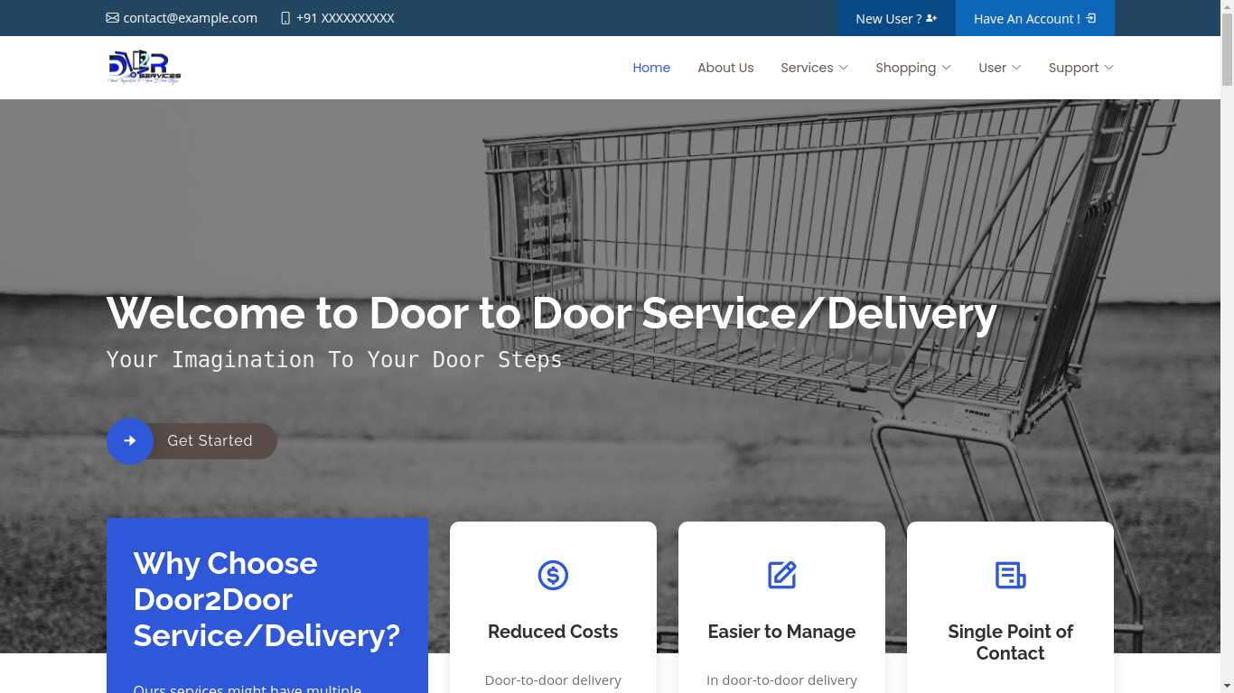

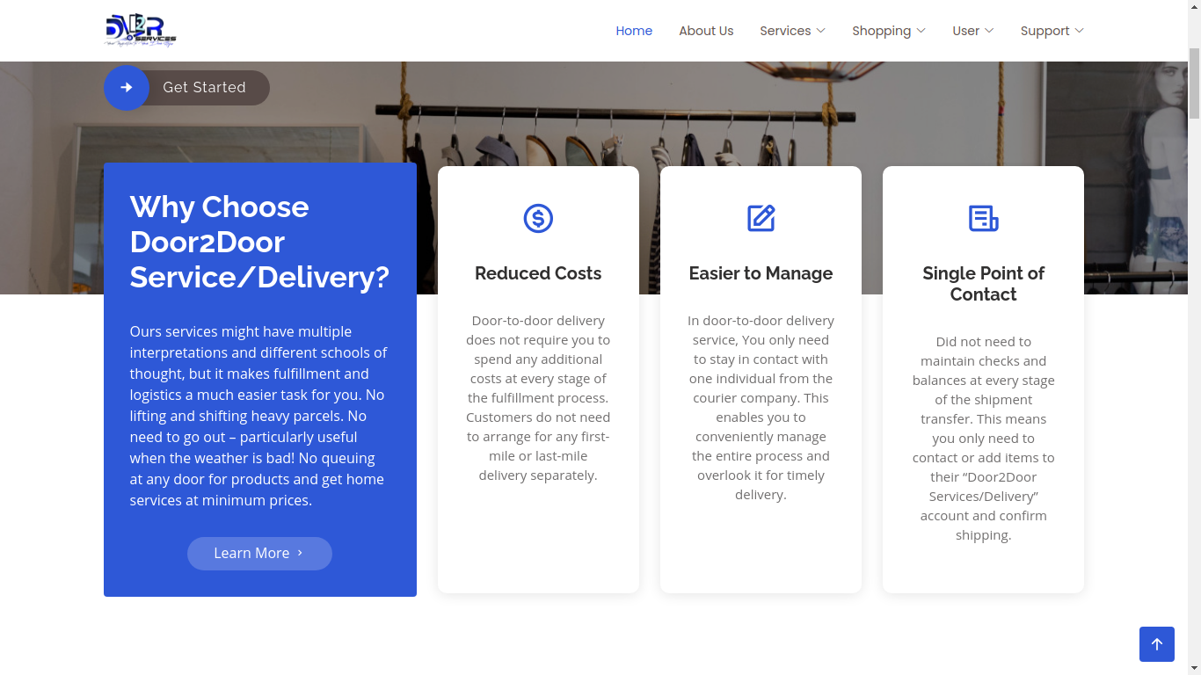

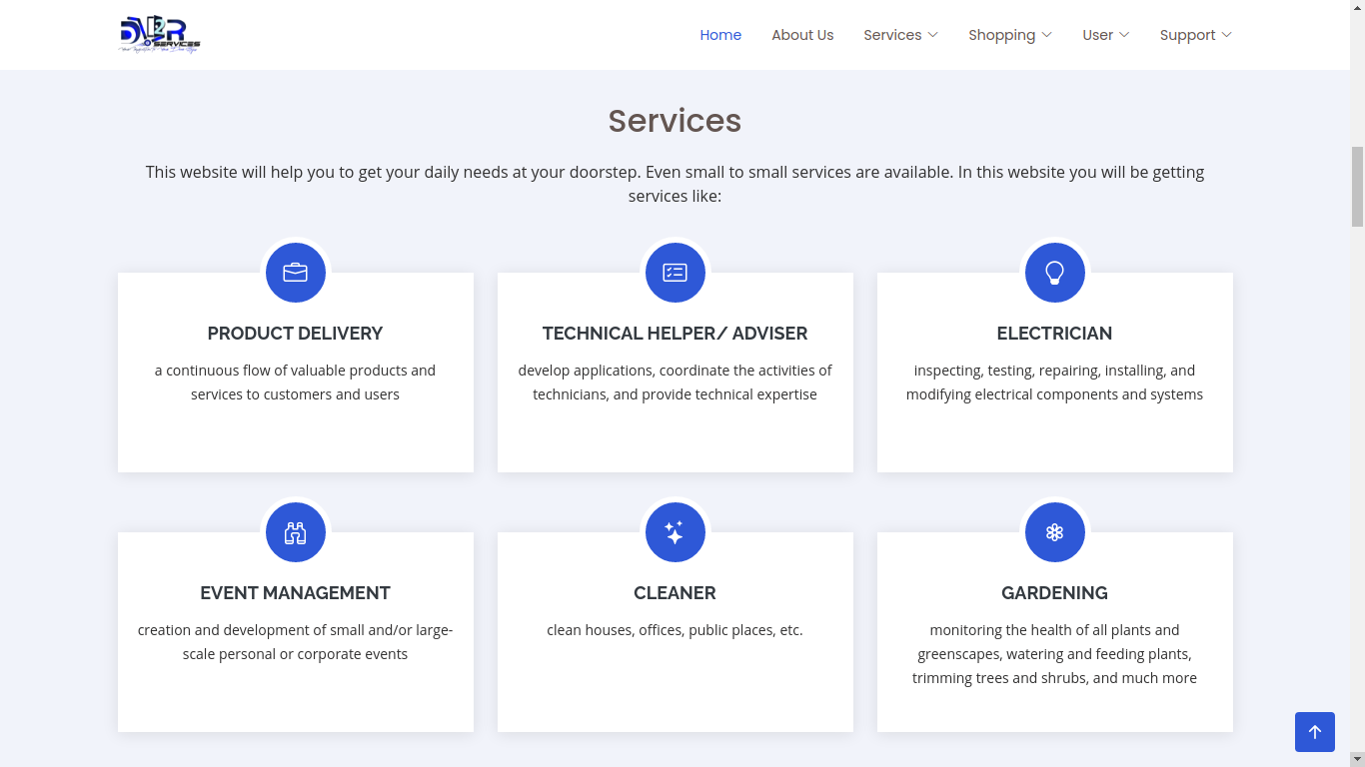

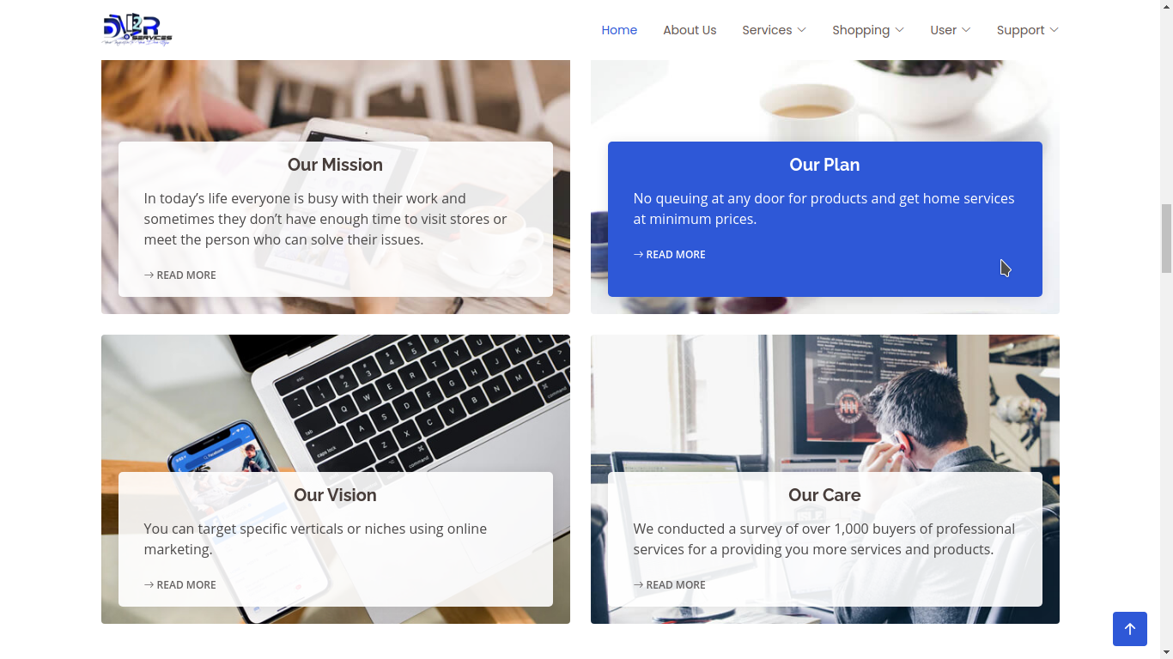

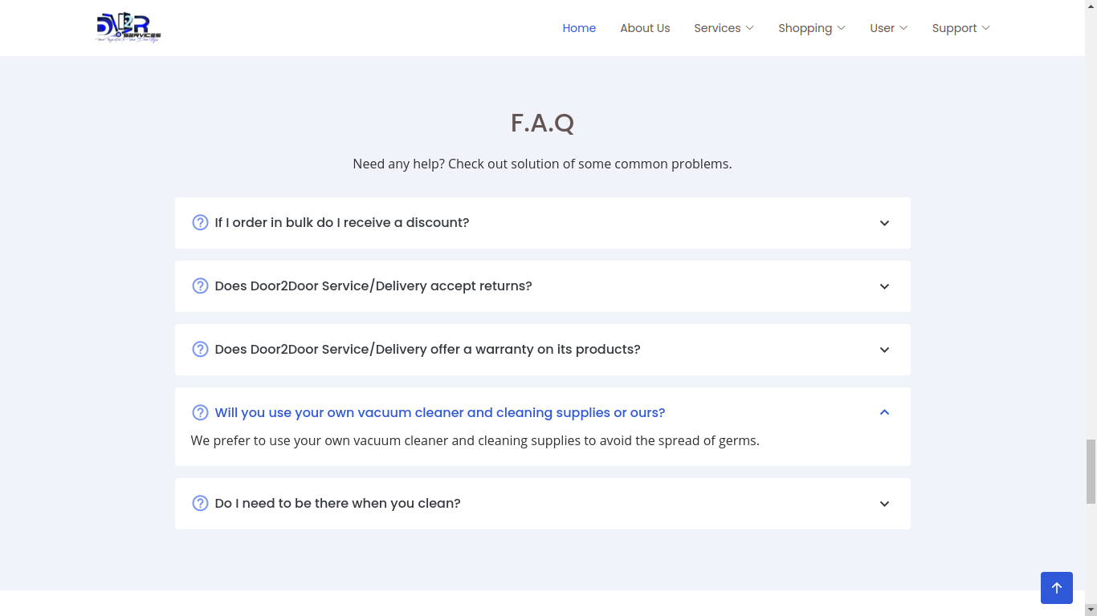

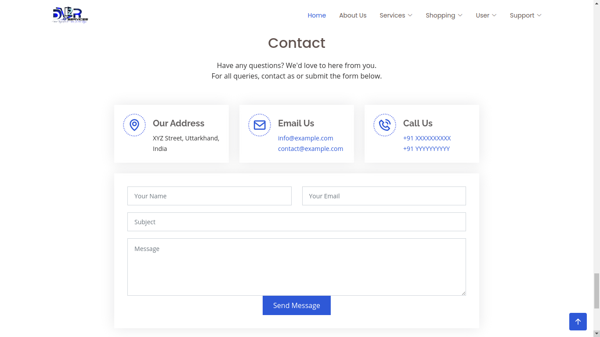

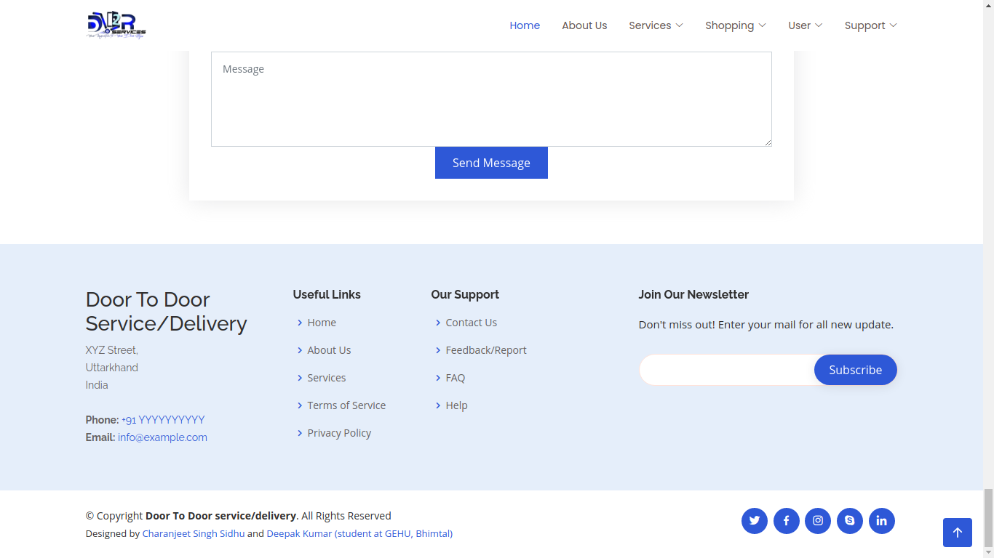

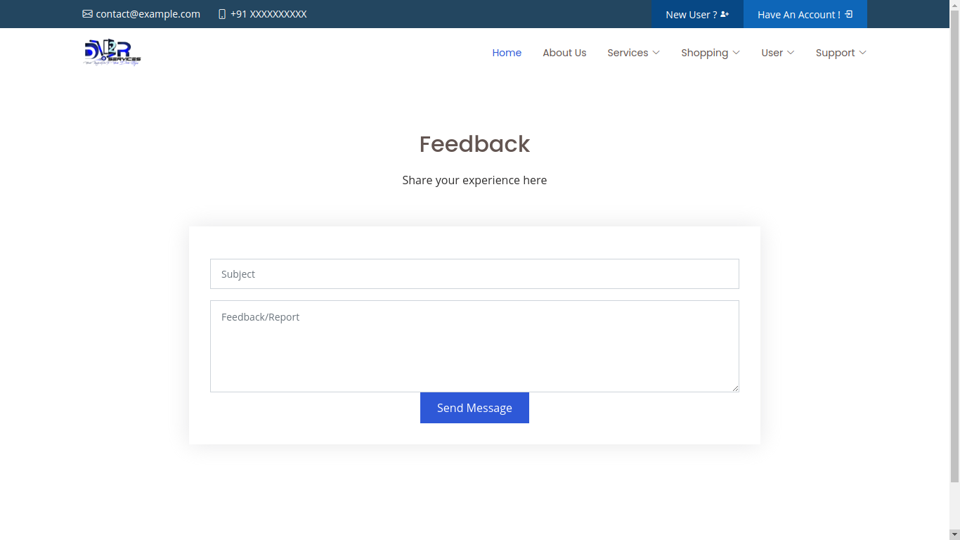

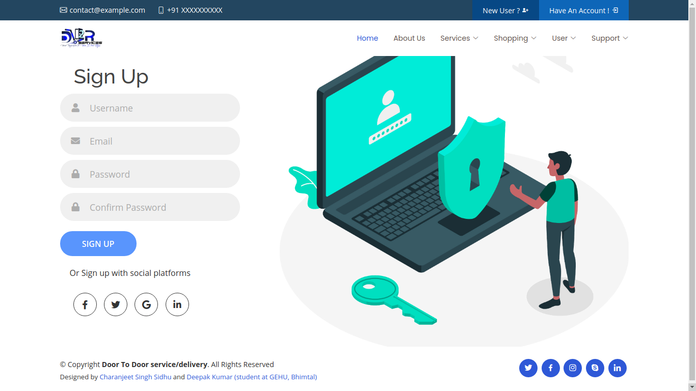

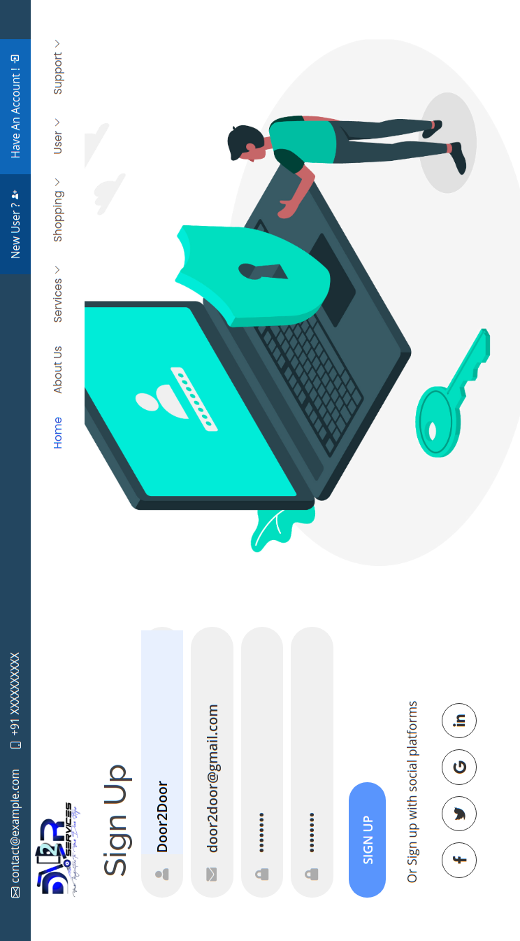

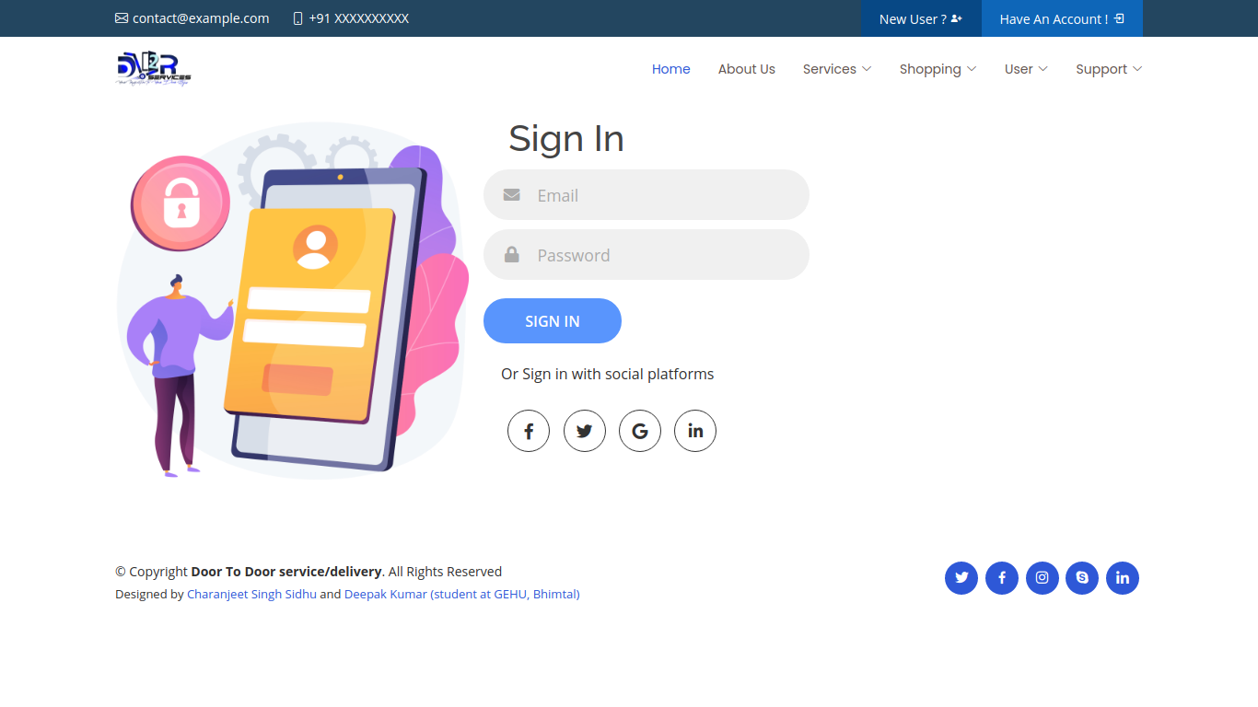

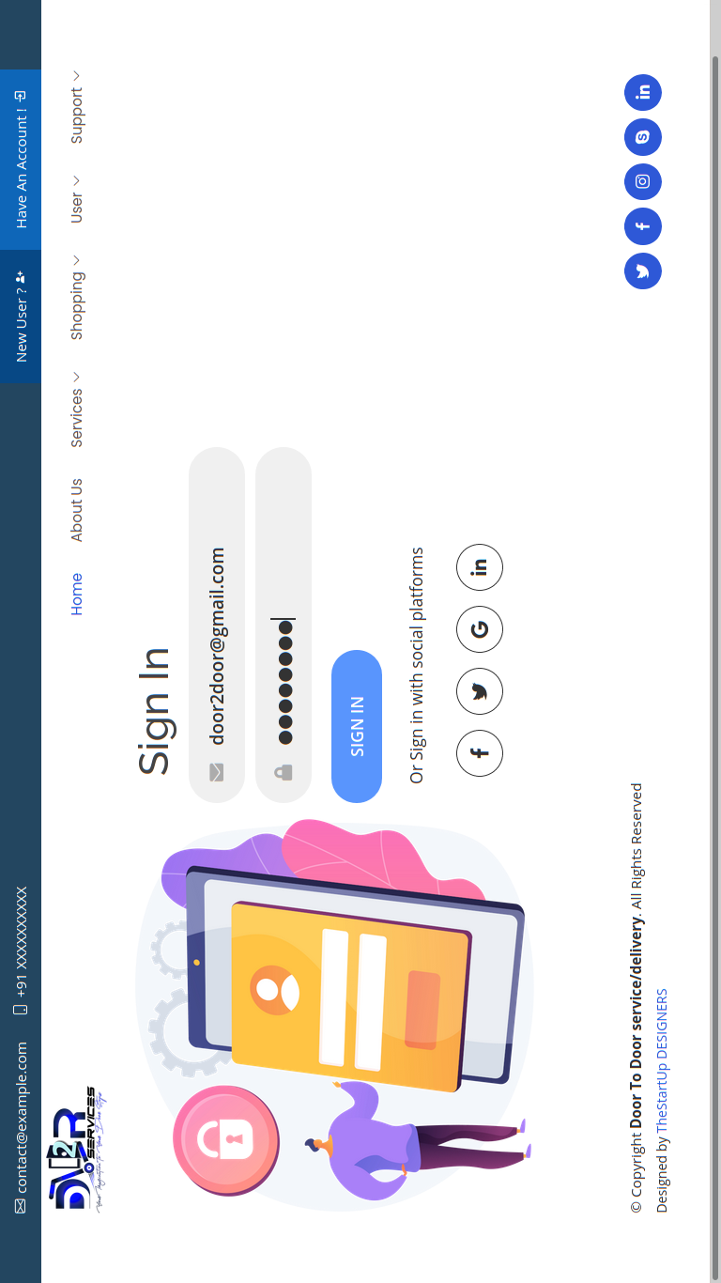

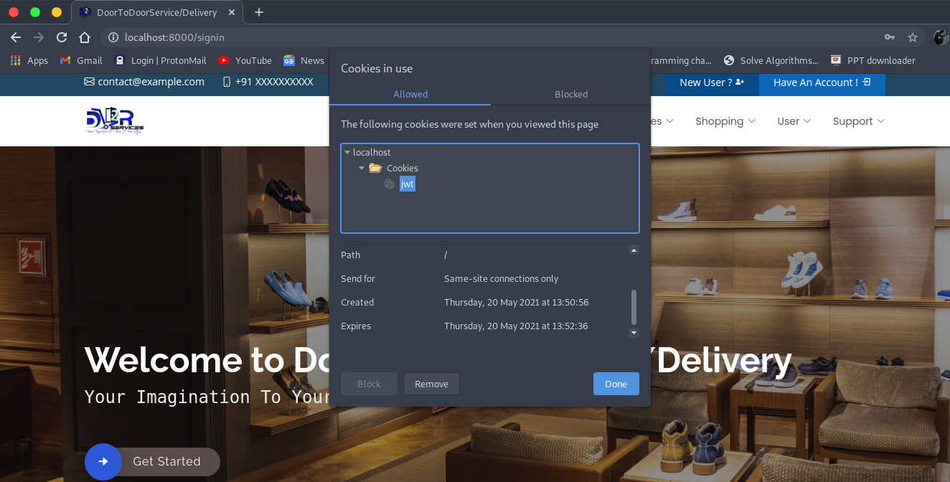

**9. CONCLUSION**

Door-to-door delivery services might have multiple interpretations and different schools of thought, but it makes fulfillment and logistics a much easier task for you. If you haven’t yet, reach out to our website “door2door services/delivery” and start delivering your products or get services at your door soon!

No lifting and shifting heavy parcels. No need to go out – particularly useful when the weather is bad! No queuing at any door for products and home services at minimum prices.

***000***000***000***

**10. ABOUT DESIGNERS**

**TheStartUp DESIGNERS**

We have started our journey with designing various websites in our projects. We aim to give our best in every project we are assigned with. Hope you will like our work and provide us with good feedback which will give us the Motivation to do our best in our upcoming projects.

**TheStartUp DESIGNERS team includes:**

* Charanjeet Singh Sidhu
* Deepak Kumar
* Gitesh Adhikhari
* Vijay Bhat

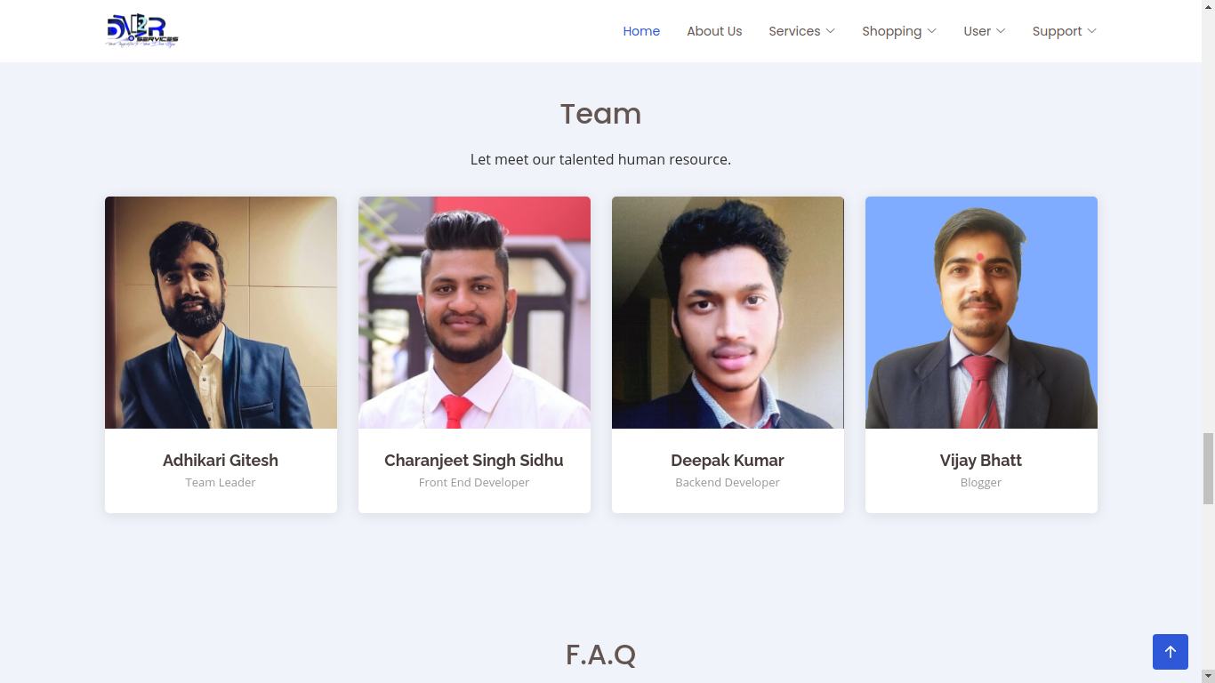

**11. REFRENCES**

**Internet Links:**

1. <https://g.co/kgs/7EBGXx>
2. <https://www.wiley.com/en-in/Web+Design+with+HTML%2C+CSS%2C+JavaScript+and+jQuery+Set-p-9781119038634>
3. <https://g.co/kgs/WXTZvi>
4. <https://stackoverflow.com/questions/12669/resources-for-getting-started-with-web-development>
5. <https://sites.google.com/site/resumereformat/file-cabinet/career-tips/how-to-write-a-impressive-synopsis-for-engineering-projects>

Books:

1. HTML & CSS: Design and Build Web Sites (By: John Duckett)
2. Learning Web Design(Book by Jennifer Niederst Robbins)
3. JavaScript and JQuery: Interactive Front-End Web Development(Book by David McFarland)